XDistrict Court Denver Probate Court  JEFFERSON County, Colorado  Court Address: 100 Jefferson County Parkway  Golden, CO 80401  In the Matter of the Estate of:  EDWARD HENRY LENCA a/k/a EDWARD H. LENCA, a/k/a  ED LENCA  Deceased | COURT USE ONLY
Party Without Attorney (Mary Hallgren):  Mary Hallgren  752 Knox Ct  Denver, CO 80204  Phone Number: 720-301-0377 E-mail: mhallgren2005@yahoo.com | Case Number:2023PR30170  Division 11 Courtroom

CLAIM AGAINST FORMAL PROBATE

Name of Claimant: Mary Hallgren
Street Address: 752 Knox Ct. Mailing address only
City: Denver State: CO Zip Code: 80204

Claim is made against this estate, itemized as follows:

Date(s) Obligation Incurred | Type or Description of Claim or Service | Amount
2012 to 2020 | Plaintiff was not notified of death of husband until February
 | CHALLENGE TO FORMAL PROBATE DATED JUNE 16, 2023
Total |  | $200.000

BRIEF STATEMENT OF CASE

- Due to informal verbal withdrawal of attorney Tom Ripp to Plaintiff on 6/16/2023, and previous Court Order Terminating Conservatorship of Virginia A. Abel, Mary Hallgren wife of deceased, is representing herself in the probate of Edward H. Lenca. She entered her two original will previously entered into the court February 2023, See attached: Original order terminating Virginia A. Frazer-Abel’s Conservatorship and receipt for records)
- Plaintiff was not notified by APS that her husband had died and had been kept away from living with hm due to their intervention. She immediately filed with court her original request for records and entered herself into court Probate proceedings 2/12/23. (See receipt for records, copies of emails with Virginia A. Abel and Plaintiff) (Attached last picture of Ed lenca, husband of Mary Hallgren Thanksgiving and Christmas when she brought him food and still alive. At that time, she noticed that his teeth were falling out due to malnutrition.)

VERIFICATION
I declare under penalty of perjury under the law of Colorado that the foregoing is true and correct.

Executed on the 21th day of June, 2023,
(date)

Debver, Colorado
(city)

Mary Hallgren

____________________________________________ __________________

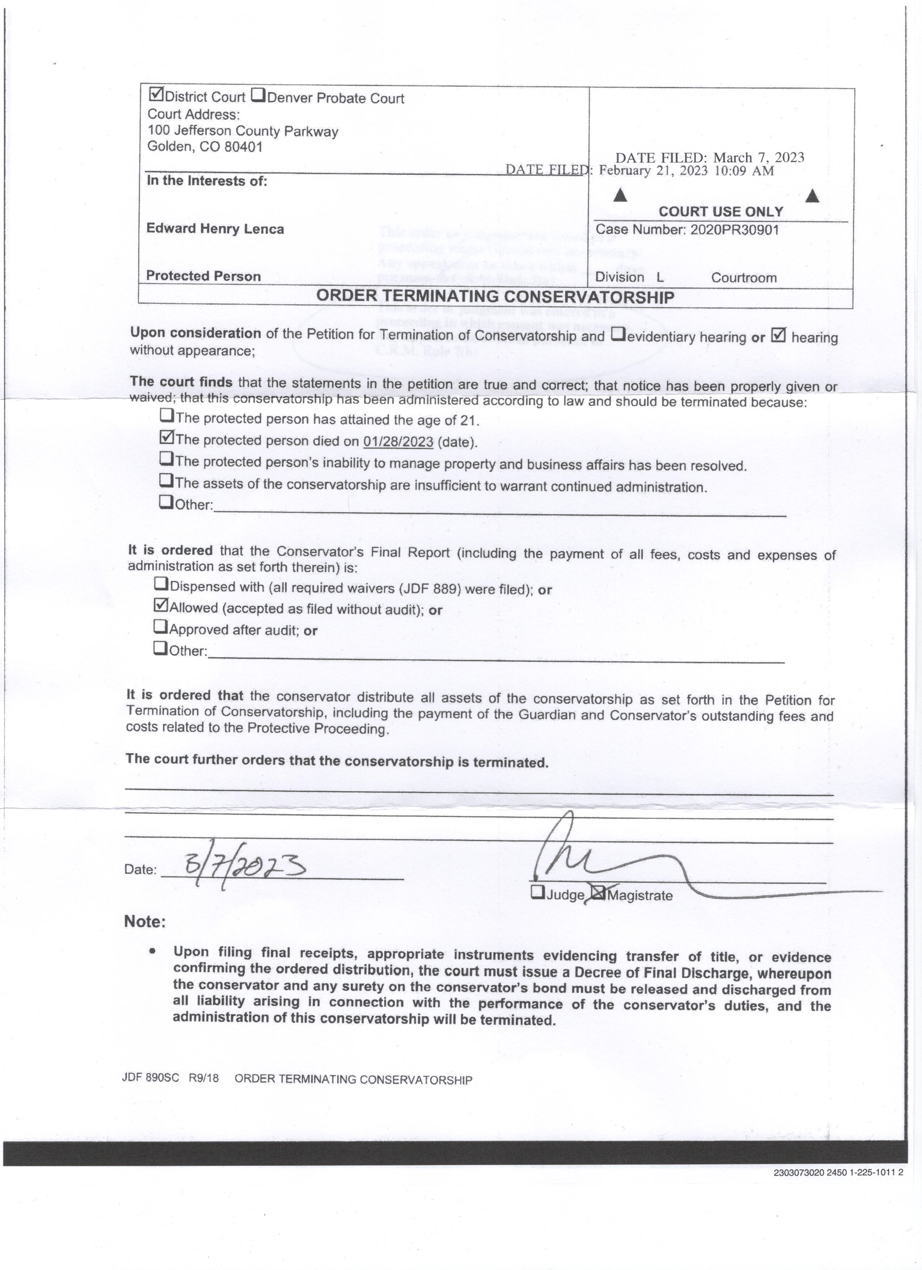
Transact ion .
2/13/2023 12:23 PM LAL ILO 1 3004 District Court, Jefferson County
100 Jefferson County Parkway
Golden, CO 80401-6002 720-772-2500 Payor: MARY case it: 2023CV-000002 ADMINISTRATIVE CASE FEBRUARY
vs . ADMIN CASE
Descript ion Amoun t
Copy Work 6 , 75
Search of Records (On Si t 5 00
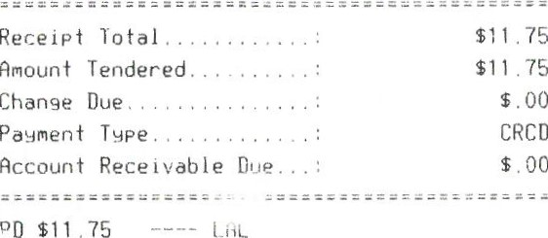
JEFFERSON COUNTY COURT
100 JEFFERSON PKWY
GOLDEN, CO 804010000
02/13/2023
CREDIT CARD

SALE
Card # | xxxxxnxxxxx6073
Chp Card: | Discover
SEQ Bath | A0000001523010
INVOICE | 1492
Approval Code. | 1
Enty Mehod: | 01352R
Mode | Chip Read  Issuer
AMOUNT | $11,75
CUSTOMER copy

