District Court, Jefferson County, Colorado 100 Jefferson County Pkwy  Golden, Colorado 80401  In the Matter of the Estate of:  EDWARD HENRY LENCA, a/k/a EDWARD H. LENCA, a/k/a ED LENCA, a/k/a Mr. Lenca  Deceased. | COURT USE ONLY
Personal Representative:  Mary Hallgren  Common Law Wife of the deceased  Mailing address: 752 Knox Ct. Denver, CO 80204  Phone: 720-301-0377  Email: mhallgren2005@yahoo.com  LONGBRIDGE FINANCIAL, LLC  Defendant  Attorneys:  Janeway Law Firm, P.C  9540 Maroon e, Suite 320  Phone No (855) 263-9294  Atty Reg# 14492 Lynn M. Janeway (lynn@janewaylaw.com)  Sandra M Sigler, $44522  Kayla R. Nelson, #46242  390 Union Blvd, Ste., 580  Lakewood, CO 80228  Phone (303)444-3025  E-mail: Sandra@SiglerLawCO.com  E-mail: Kayla@SiglerLawCO.com  Virginia A. Frazer-Abel 4704 Harlan Street, #250 Denver, CO 80212  Steven Lenca 2509. P.O. Box 57 Wells, MI 49894 nikkoblue1@yahoo.com  Carol Witt 2509 Park Ridge DR. Granger, IA cwit@carolsitt@yahoo.com  Keith Hurtubise 5995 South Jellison Street, Unit E Littleton, CO 80123, (303-808-8203) | Case Number:2023PR30170  Division: 11  Courtroom
RESPONSE TO STAY OF DEADLINES PENDING COURT ORDER

- COMES NOW, MARY HALLGREN, original personal representative of Edward H. Lenca, as established by the wills provided to her in 2012 and 2018, and files her objection for Stay of Deadlines Pending Court Order and injunction against sale of property.
BACKGROUND & LEGAL ARGUMENT(S)
Frivolous Claims by Defendant:
- Plaintiff, MARY HALLGREN, alleges that the Defendant, VIRGINIA A. FRAZER-ABLE, and her attorneys have been filing various pleadings with this Court in an attempt to create billable hours against the estate and perpetrate fraud against the Plaintiff. The pleadings fail to reference Plaintiff’s will and are aimed at preventing the case from proceeding to trial.
(Proof of original wills filed with court designating Mary Hallgren as the common-law wife of Edward H. Lenca is herein attached as Exhibit A)

- The Plaintiff further asserts that Mike and Marlene Baugh and Keith Hurtubise filed frivolous and fabricated claims concerning a fake will after Mr. Lenca was declared incompetent, and the Defendant is entirely basing and supporting her claims based on these frivolous actions. Other than that, the Defendant has no valid basis to support her baseless contentions. Plaintiff places reliance on Bd. of Comm'rs v. Eason, 976 P.2d 271, 272 (Colo. App. 1998) in which the Colorado Court of Appeals held that “A claim is frivolous if the proponent can present no rational argument based on the evidence or law in support of the claim. A claim is groundless if the allegations in the complaint, while sufficient to survive a motion to dismiss for failure to state a claim, are not supported by any credible evidence. A vexatious claim is one brought or maintained in bad faith. Bad faith may include conduct, which is arbitrary, vexatious, abusive, or stubbornly litigious, and may also include conduct aimed at unwarranted delay or disrespectful of truth and accuracy.” [Emphasis Added] Based on this, the Plaintiff maintains that Defendant's claims lean precariously on the fraudulent actions of certain individuals, namely, Mike and Marlene Baugh and Keith Hurtubise, who have filed frivolous and fabricated claims concerning a counterfeit will. It is incumbent upon this Court to recognize that such spurious actions can in no way lend credence or legitimacy to the Defendant's arguments. Rather, it reveals the Defendant's willingness to grasp at any straw, however insubstantial, in her misguided pursuit of victory.

(Proof of assessment previously recorded with court is herein attached as Exhibit B)

- The Plaintiff also contends that Marlene and Michael Baugh, former friends of Keith Hurtubise, made false statements against her as documented in Detective Monn's report, which initiated the current legal process with Keith Hurtubise's assistance. The Plaintiff reiterates that the Defendant is barred from supporting her claims on the basis of these false statements and otherwise presents no other credible evidence.
(Proof of other abuses by Keith Hurtubise and Detective Monn’s report is herein attached as Exhibit C)

- The Plaintiff again reiterates factual assertions that the property at 350 Harlan St., Lakewood, CO 80226, was previously in Plaintiff’s name until September 28, 2020, when she transferred it to her husband's name due to APS (Adult Protective Services) taking over his care. At that time, it was believed that he would outlive Plaintiff, who is twelve (12) years his senior. However, Ed Lenca passed away only two (02) years later, and APS collected money from various sources, including his gun collection, ammo, SSI, and cash from his safe. Detective Monn's report, attached to Defendant’s earlier filing, confirms that the property is not the sole asset of the estate.
(Proof of Mary Hallgren's Property Deed to Mr. Lenca is herein attached as Exhibit D)
Violating Duty to Act in Best Interest of the Estate:
- The Plaintiff also disputes that the Defendant is genuinely representing the family's interests; in support of this, the Plaintiff cites a text from Mr. Lenca’s brother, Steve, expressing disinterest in the property and claiming that Keith Hurtubise fraudulently included their name in the last will to give the appearance of legitimacy.
(Proof of brother Steve's text to Plaintiff is herein attached as Exhibit E)

- It is further alleged that the property has been neglected, with no repairs conducted except for periodic visits by a lawyer to ensure no one is living on the premises. A neighbor has reported that the fence is falling on their side, and pictures have been provided as evidence of this negligence.

- A personal representative is a fiduciary. Colo. Rev. Stat. § 15-1-802(3)(a)(I) (2019). “She has a duty to act reasonably and equitably with due regard for her obligations and responsibilities toward the interests of beneficiaries and creditors, the estate or trust involved, and the purposes thereof.” Colo. Rev. Stat. § 15-1-804(1) (2019). Treviño v. Treviño (In re Estate of Treviño), 2020 COA 125, ¶ 1, 474 P.3d 223, 225. Based on this, the Plaintiff contends that the Defendant, as the alleged personal representative, has breached her duties towards Mr. Lenca’s estate; the Defendant aims to sell the property solely for her own benefit and to deprive Plaintiff of her rights as Ed Lenca's common-law wife and beneficiary of his recorded wills.

(Proof of dated pictures of Mr. Lenca passed out drunk and the filthy condition of the place is herein attached as Exhibit F)

Wrongful Foreclosure:

- It is further alleged that Longbridge Financial LLC erroneously placed a reverse mortgage on the property at 350 Harlan St in Ed Lenca's name only, which was an oversight and attempted cover-up by the Defendant, Virginia A. Frazer-Able. The Plaintiff contends that this occurred despite Ed Lenca and herself being recognized as common-law husband and wife by the Defendant’s records and a statement from Diane Head confirming their marital status.

(Proof of references to common law wife in VA records is herein attached as Exhibit G)

- The Plaintiff brings attention to the impending foreclosure of the property, scheduled for September 28, 2023, and requests a stay of foreclosure. Despite several attempts to take over the loan to prevent foreclosure, her requests have been unsuccessful. “[T]he “better practice” under the applicable statutes and circumstances was to stay the sale pending final resolution of issues concerning the title to the property.” [Emphasis Added] Royal Thrift & Loan Co. v. Cty. Escrow, Inc., 123 Cal. App. 4th 24, 34, 20 Cal. Rptr. 3d 37, 45 (2004). Based on the foregoing, the Plaintiff maintains that granting the stay is essential to safeguard Plaintiff’s rights as the original personal representative and common-law wife of Edward H. Lenca. Without the stay, the ongoing actions by the Defendant and her attorneys, coupled with the pending foreclosure of the property, could irreparably harm Plaintiff’s ability to defend herself in court and protect her interests in the estate. The alleged fraud, fake will claims, improper reverse mortgage, false statements, and neglect of the property underscore the urgency of halting any further proceedings until all relevant evidence can be presented fairly. Granting the stay will ensure a level playing field, allowing Plaintiff to thoroughly present her case and receive just and proper relief in accordance with her rightful status as the representative of her late husband's estate and his true common-law wife.
RELIEF / PRAYER
- The Plaintiff seeks the following relief from the Court:

- A stay on the sale of the property, due to Defendant’s attempt to rush to judgment.
- An order for a complete list of the estate's value, including the sale of guns, ammo, cash, and monthly collection of SSI by Defendant. It is further requested to have Guardian Jeanette Goodwin's misuse of funds, particularly the purchase of gift cards, reimbursed, as it is currently being concealed.
- A stay on the authority of the Defendant as alleged personal representative as Plaintiff believes that Defendant’s role as conservator should have ceased upon Mr. Lenca's death. Furthermore, Plaintiff contends that the Defendant is not representing Ed Lenca's family but is rather acting in the interests of the corrupt real estate broker, Keith Hurtubise, who allegedly acted deceitfully to create a will after Ed's incapacitation.
- Withdrawal of a previously offered settlement.
- The Court's instructions and fair relief, as deemed appropriate and just.

- In light of the presented evidence and claims, Plaintiff, MARY HALLGREN, urges the Court to consider the matter carefully and make a ruling that upholds justice and protects her rights as the rightful personal representative and common-law wife of Edward H. Lenca.

/s/ Mary Hallgren
Mary Hallgren
Mailing address: 752 Knox Ct. Denver, CO 80204
Phone: 720-301-0377
Email: mhallgren2005@yahoo.com
Plaintiff, Pro Se

Date: July 25, 2023 ____________________________________

I hereby certify that on this 24th day of July 2023 a copy of the foregoing RESPONSE TO STAY OF DEADLINES, REMOVAL OF VIRGINIA A. FRAZER-ABLE AS PR STAY OF SALE OF PROPERTY AND WITHDRAWAL OF SETTLEMENT OFFER BY 5 pm 7/24/23 SUBMITTED July 24, 2023 was served on the following by CCES and USPS 1st class or hand delivered to the parties as follows:

DISTRICT COURT, JEFFERSON COURNTY COLORADO Hand Delivered
100 Jefferson County Parkway
Golden, CO 80401

Virginia A. Frazer-Abel USPS Mail
4704 Harlan Street, #250
Denver, CO 80212 including Kayla R Nelson and Sandra M Siger

Steven Lenca 2509. P.O. Box 57 Wells, MI 49894 USPS Mail
nikkoblue1@yahoo.com

Carol Witt, 2509 Park Ridge DR. Granger, IA
(email: cwit@carolsitt@yahoo.com USPS Mail

Keith Hurtubise, USPS Mail
5995 South Jellison Street, Unit E Littleton, CO 80123, (303-808-8203)

LONGBRIDGE FINANCIAL, LLC in the matter of Edward H. Lenca USPS Mail
Janeway Law Firm, P. C. 4540 Maroon Circle, Suite 320 Englewood, CO 80112
Phone No. (855) 362-8294
/s/ Mary Hallgren
Mary Hallgren
Mailing address: 752 Knox Ct. Denver, CO 80204
Phone: 720-301-0377
Email: mhallgren2005@yahoo.com
Plaintiff, Pro Se

Date: July 25, 2023 _________________________________________________

Exhibit A Wills from Ed Lenca
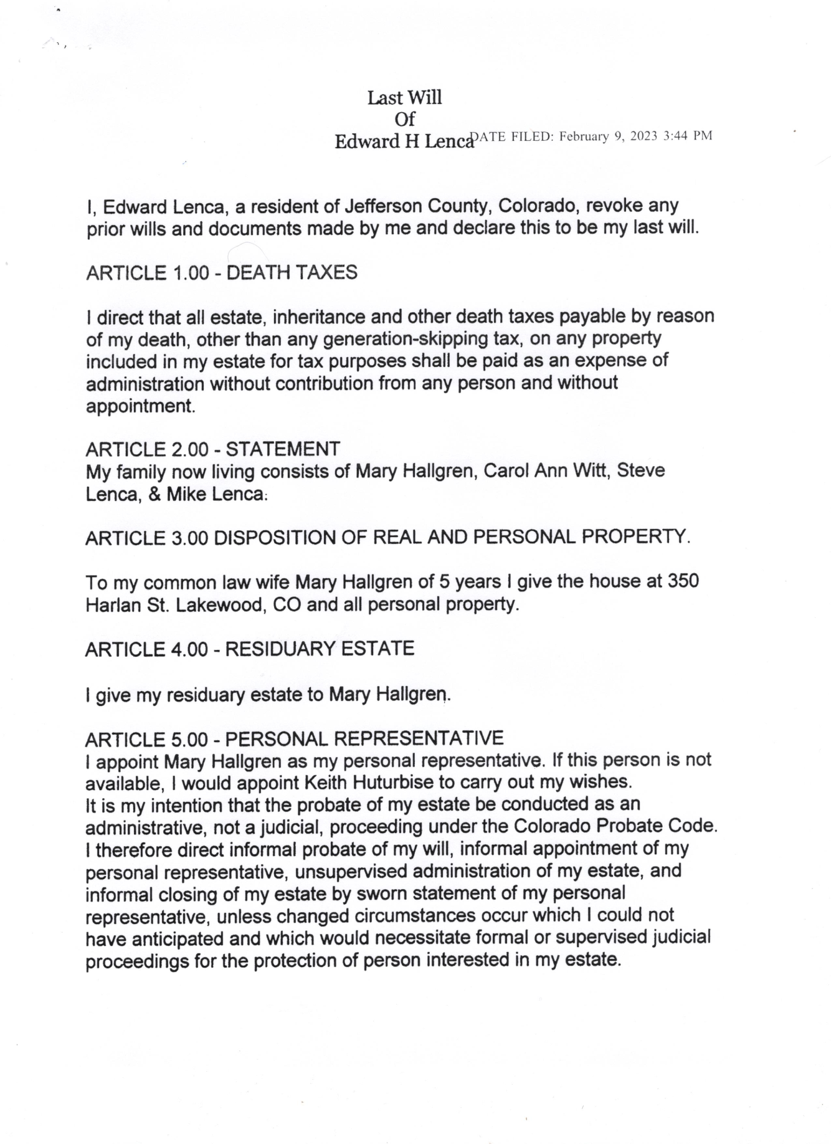
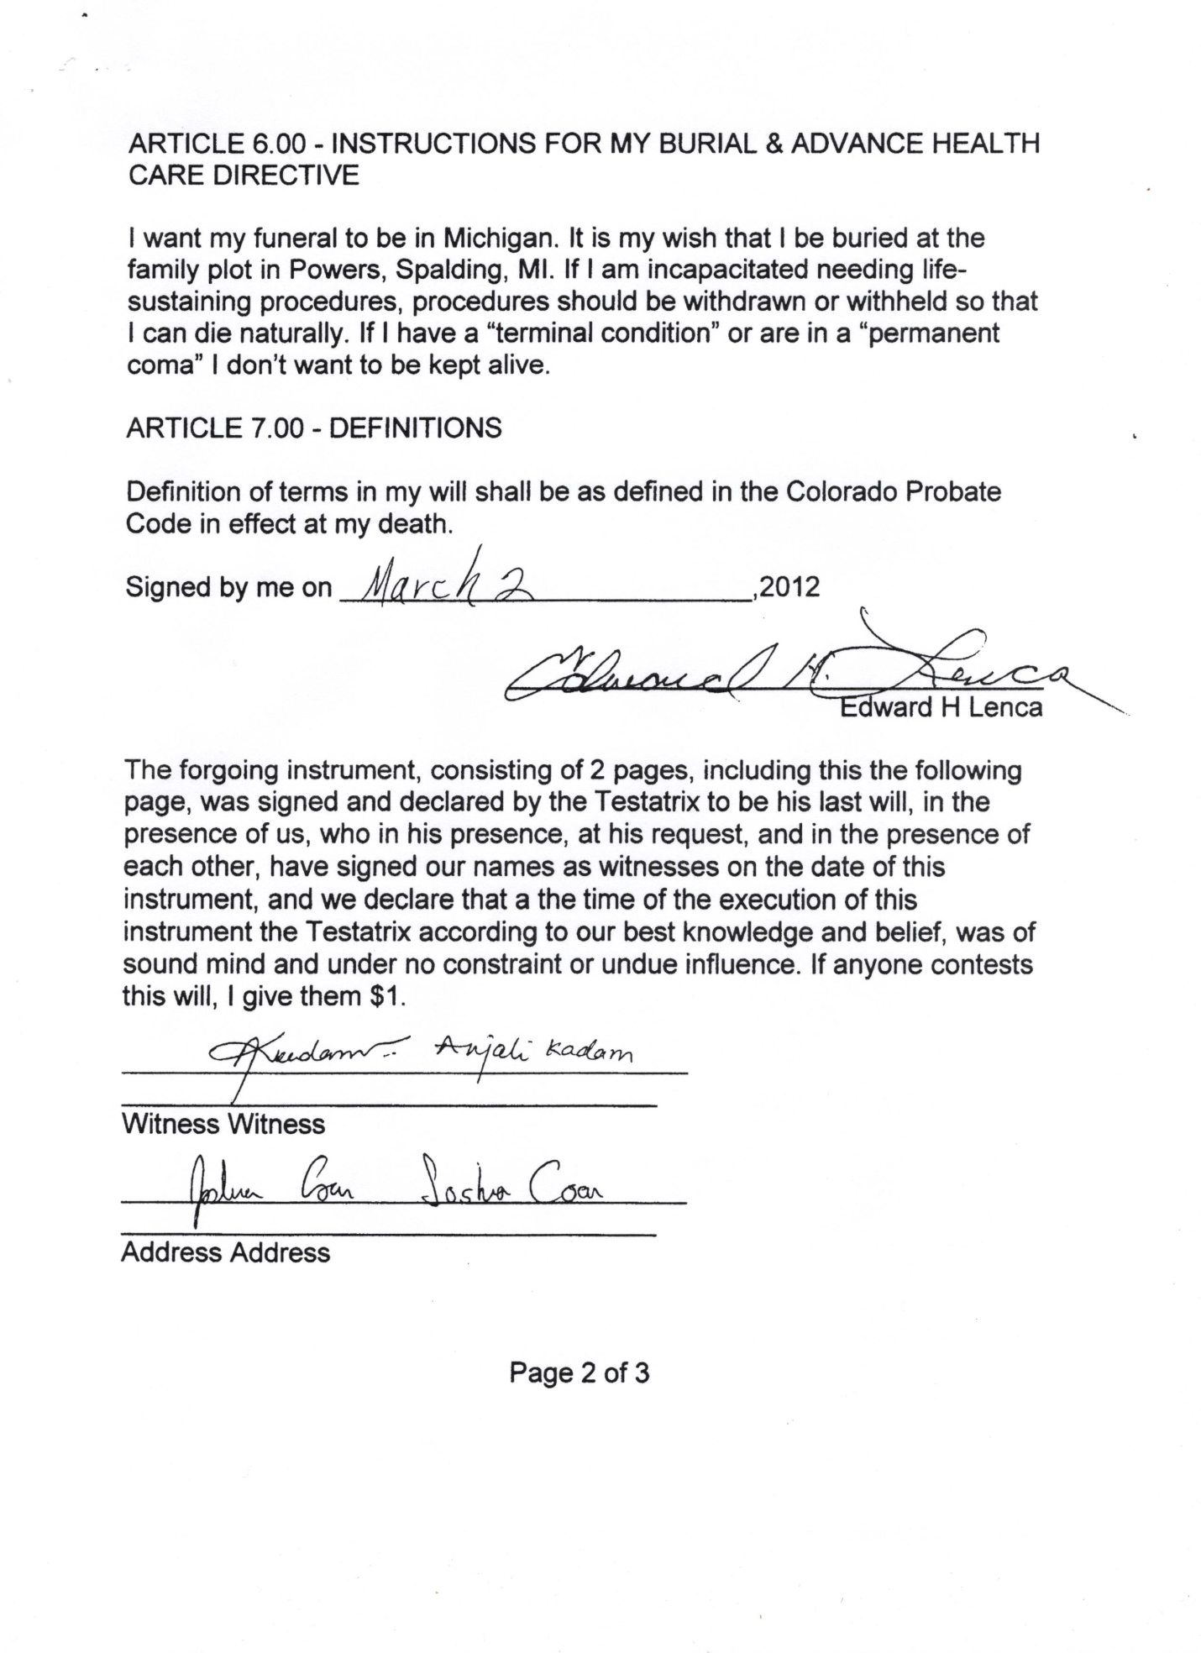
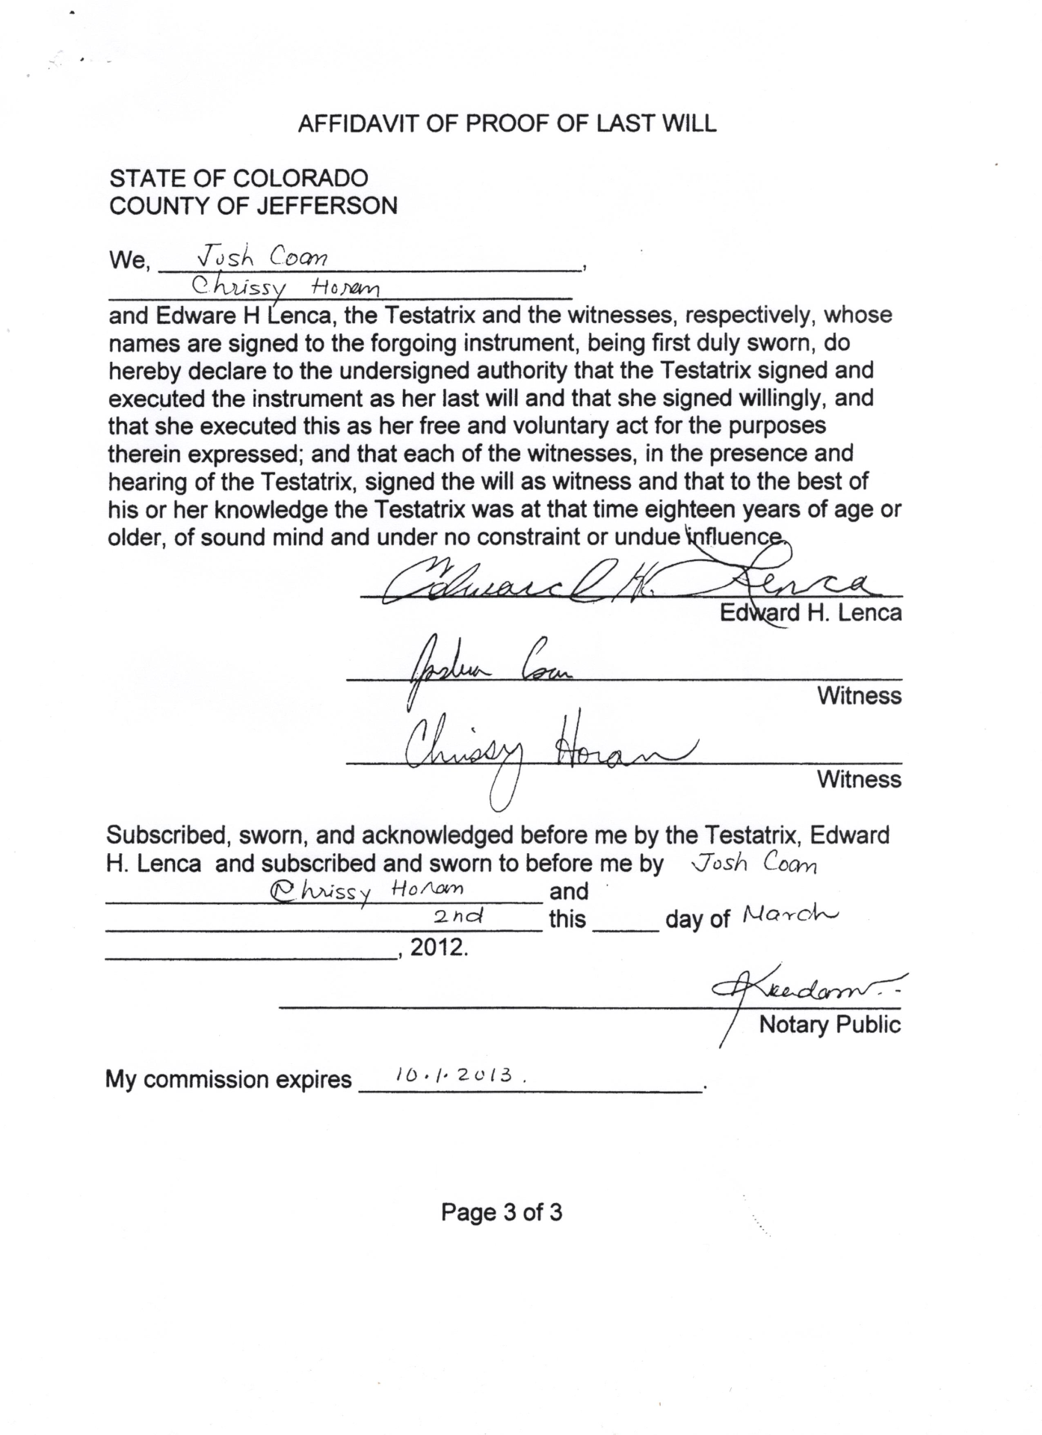
Contact with person witnessing 2012 will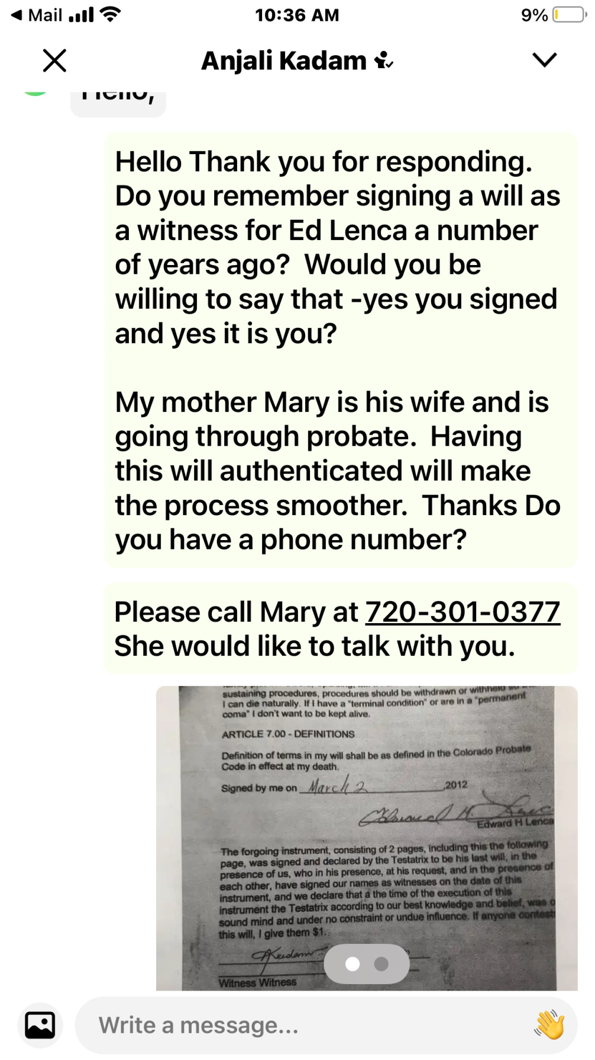
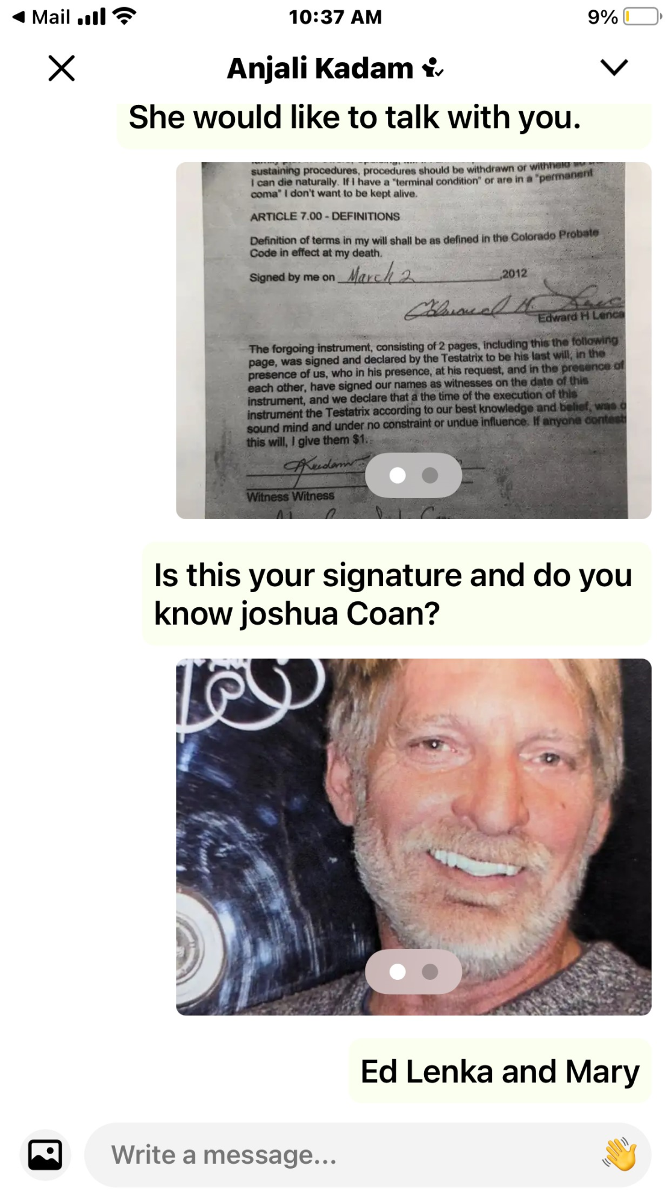
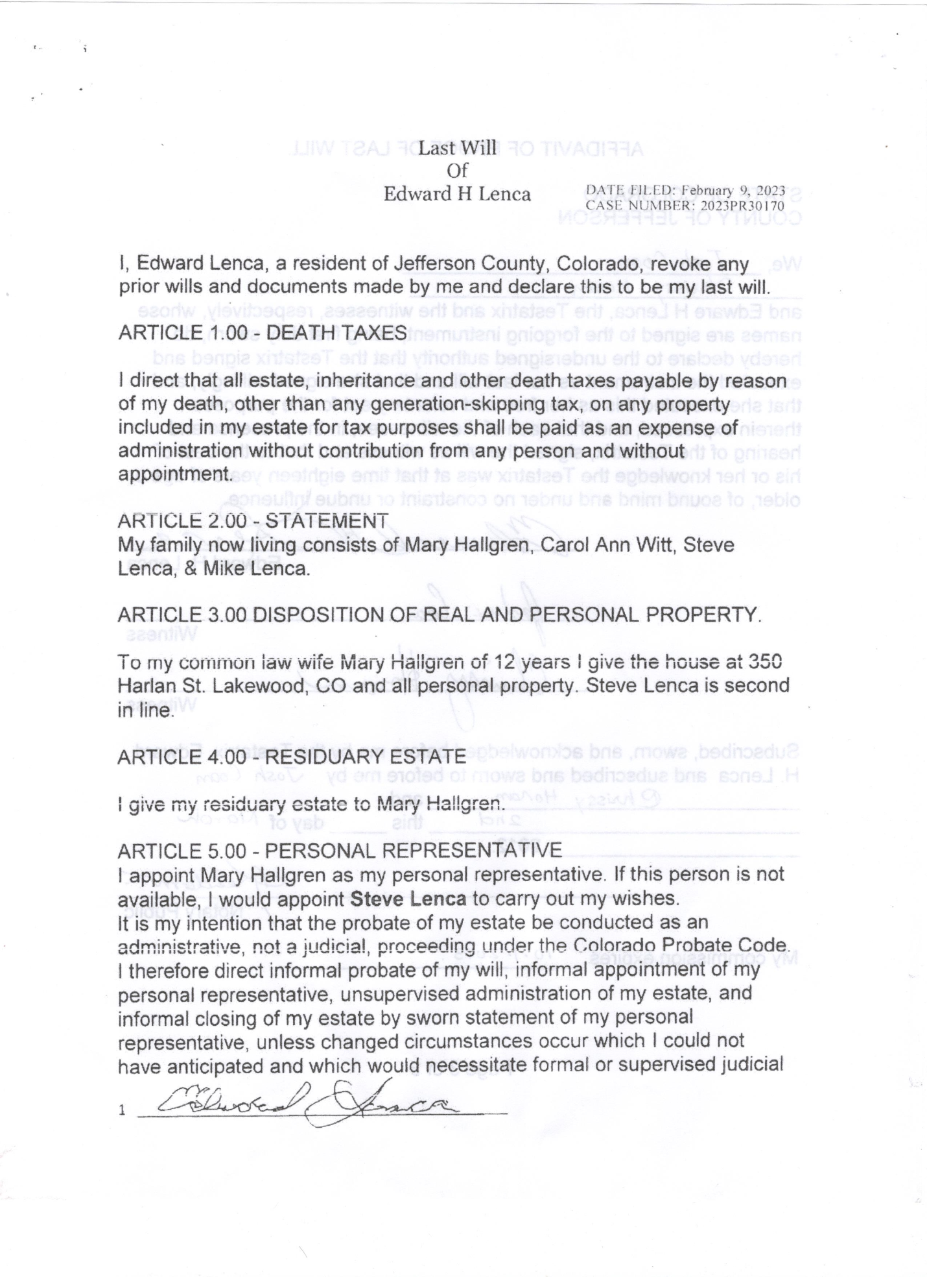
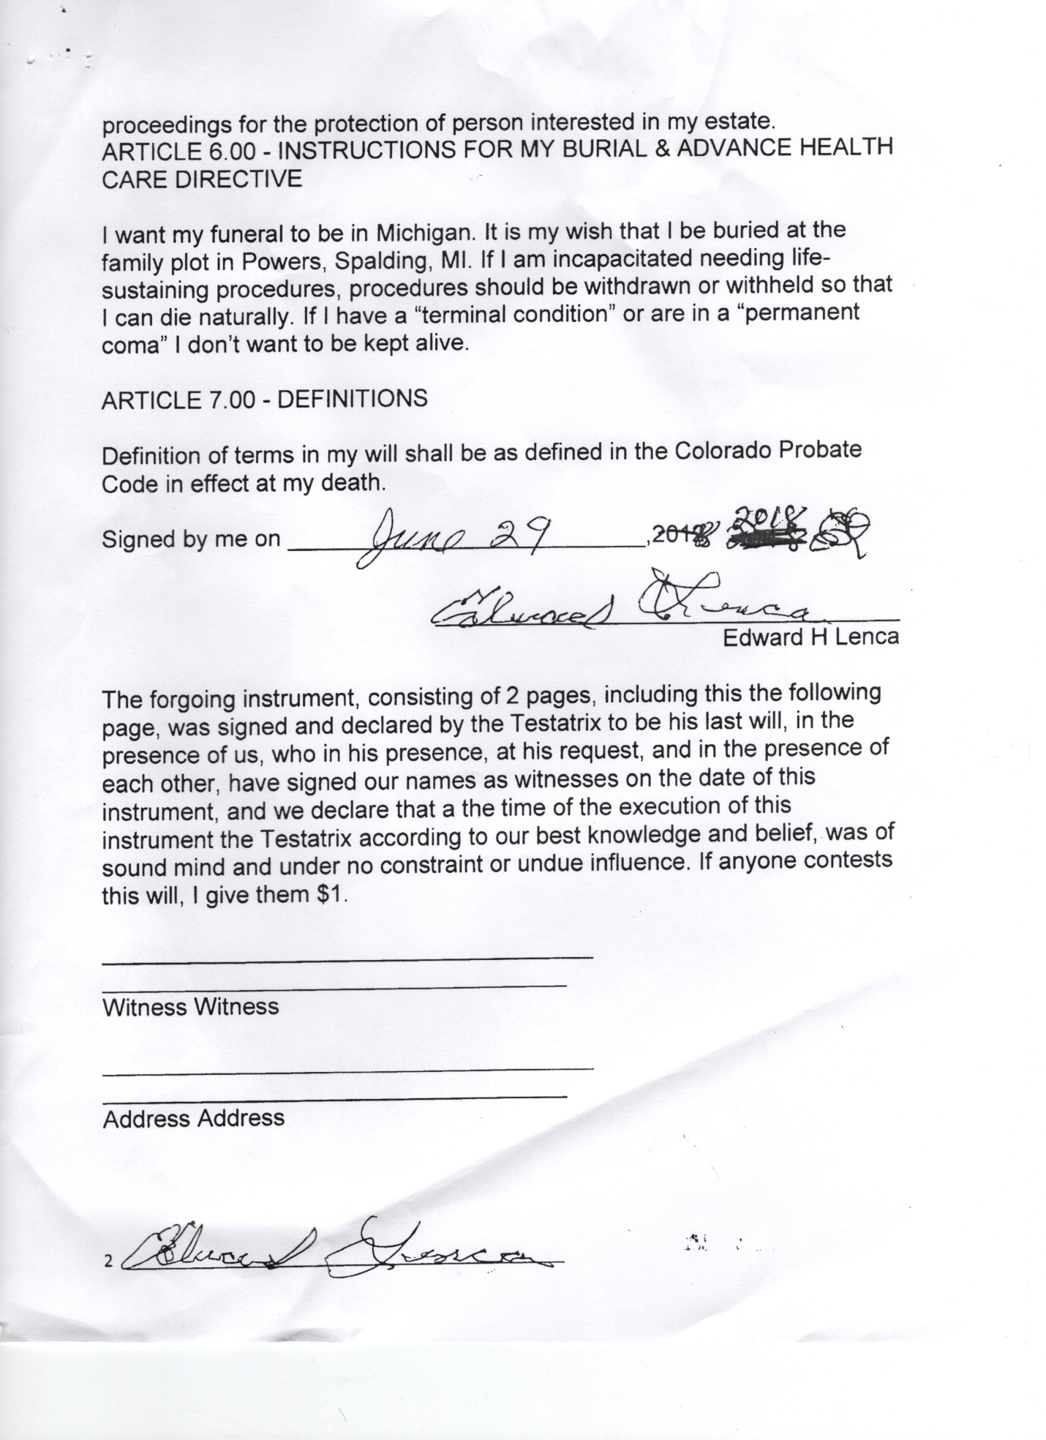
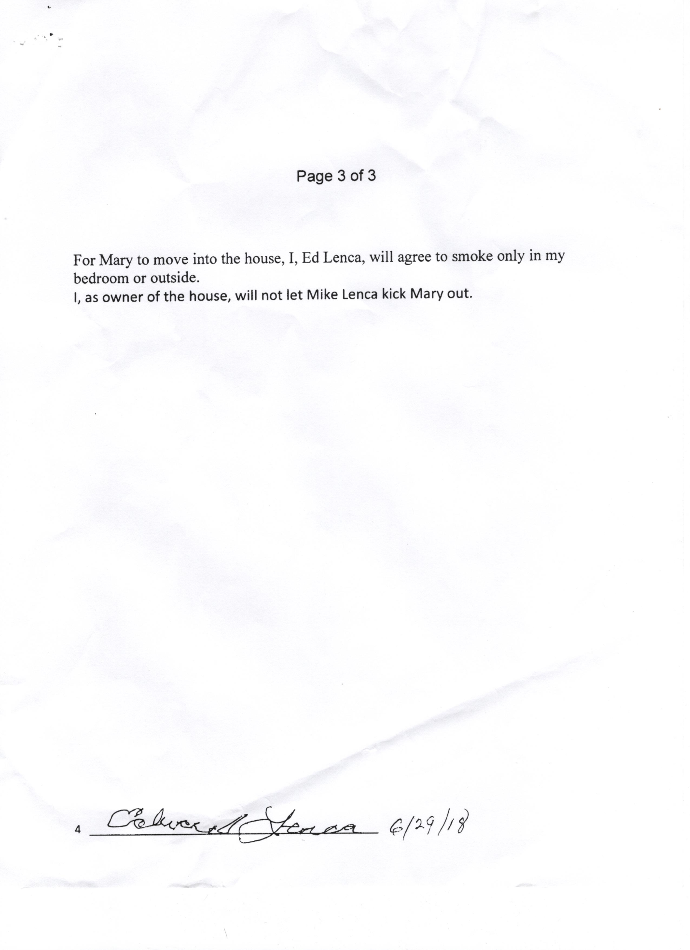
Exhibit B Assessment of Ed Lenca by APS
Psychological
Assessment and
 Treatment
Health
Services

PATHS Center, LLC
2860 Ames st. Wheat Ridge, CO 80214
Tel: 303-824-0132; Fax: 303-524-6451
Neuropsychological/Capacity Assessment

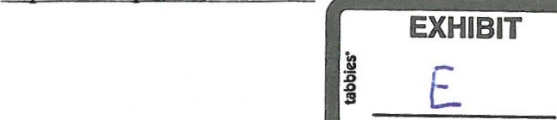
Edward Lenca
Date of Birth: | July 15, 1953
Dates of Evaluation: | October 17, 2020
Date of Report: | October 26, 2020

Referral
Mr. Lenca was referred for a neuropsychological/capacity assessment. The evaluation was intended to assist in determining Mr. Lenca's present level of cognitive functioning and to help determine his ability to make sound healthcare, financial, and other important decisions for himself.
Specifically, the present testing was done to 1) determine the patient's overall level of psychological and cognitive functioning; 2) determine what specific organically-based cognitive deficits may exist; 3) discuss the implications of such deficits for day-to-day functioning; 4) discuss rehabilitation potential; 5) provide recommendations for possible future treatrnent procedures and strategies 6) determine capacity/incapacity to make decisions conceming his

Procedure
Clinical Interview; Wechsler Memory Scales — Fourth Edition
Mental Status Exam; (WMS-IV);
Review of Records; Collateral Information
Independent Living Scales (ILS);

Mental Status Exam
A mental status examination was conducted. Mr. Lenca is a 67-year-old male who appeared his stated age. He is of normal height and weight. Mr. Lenca was a pleasant conversationalist during this interview. He presented as disheveled and unkempt. He was polite, appropriate and guarded. He has never married and has no children. Mr. Lenca has lived with women in the past and has dated.
Review of Records

Jefferson County Adult Protection Legal Referral, dated August 13. 2020
The following was reported: Edward Henry Lenca, date of birth: July 15, 1953. Mr. Lenca lacks ability to an understanding of his finances. He is not able to make sound decisions regarding his finances and assets nor is he able to make reasonable decisions regarding his finances.
Dr. Christina Mulkey stated that she saw him twice, once in September 2018 and once in February 2019. Dr. Mulkey stated that based on that interaction, Mr. Lenca did not have the ability to understand or follow through in making his own doctor's appoinünents let alone the ability to make complex financial decisions.
Mr. Lenca is susceptible to ongoing financial exploitation due to an inability to understand, freely access, or manage his finances.
Jefferson County Adult Protective Services received a report of concem on July 27, 2020 regarding caretaker neglect and exploitation. The report alleged Mr. Lenca appeared dirty, had no food in his home and many of his assets appeared to be missing. Caseworker Head and Caseworker Ibbott visited and spoke to Mr. Lenca at his home. Caseworker Head found Mr. Lenca to be living in squalor with no access to appropriate food.
Caseworker Head found him to be significantly confused. Mr. Lenca had several pill bottles in is noz several pills spilled onto his nightstand: Mr. Lenca was not able to articulate what ifs n:dicaEon was for or why he was prescribed the medications.
Based on the above information, there is reasonable belief that Mr. Lenca lacks the cognitive abilities to make his own financial decisions and is at risk of his assets being depleted.

Jefferson County District Court. Petition for Appointment ofConservator. dated August 26. 2020
The following was reported: Mr. Lenca is a 66-year-old man who resides in Lakewood, Colorado. The Division received a report of concern regarding caretaker neglect and exploitation. Mr. Lenca is reported to have begun showing signs of significant cognitive decline in 2018. In 2019 he fell and hit his head and was hospitalized. Further, he is reported to have ongoing substance abuse issues related to alcohol.
Clinical Interview with Mr. Lenca
Mr. Lenca was born in a small town in Michigan on July 15, 1953. His father worked in the timber industry his mother was a housewife. Both have passed on, but he does not remember when, stating, "A number of years ago." Mr. Lenca has one sister and two brothers —one lives in upper Michigan, one in Texas... "all over the place."
Mr. Lenca went to the United States Marine Corps after high school and was a Sergeant in a communications company. He was in the military for four years at Camp Pendleton. He went into the construction industry and was "all over the country. Mr. Lenca moved to Denver 15 or 18 years ago and bought his house ten years ago he thinks... "Not really sure. I don't have a good conception of
He retired "maybe eight years ago" and gets "a couple hundred bucks a month" from Social Security, which he said is "not enough." Mr. Lenca claimed that his house is paid off because he paid $1000 a month instead of $300 per month. He thinks the place is worth $250,000.

Mr. Lenca again asked why this Evaluator was doing the present evaluation with him and it was again explained to him that someone had called Adult Protection Services due to a concern that a woman named Mary was taking advantage of him. Mr. Lenca simply responded "No." When pressed about the woman having his house in her name he replied, "Yeah, maybe I did that. She can have the place when I die. I'd have no use for it." He did not remember the day he went with Mary to sign over the quit claim deed in front of the notary.
Regarding the Corvette, motorcycle and guns that are now missing, Mr. Lenca said that he had sold them. He thinks the Corvette was worth $15,000 and the 1946 Harley $15,000. He banks at 1 ^{st} Bank. He was quite resistant and "frankly insulted" that this Evaluator asked him to show a bank statement and explain it. Mr. Lenca said he did not know where they were, and that in any case, it was all "automatic." He uses a debit card for shopping and utilities are automatically deducted from his account.
Mr. Lenca's only health problem is "just being old." He claims that he takes no medication (which is unü•ue). He claims to have a driver's license and drives his truck to shop. He has occasional phone conversations with his siblings.
Mary was an ex-girlfriend, and they are "still friends" who he said lives in Denver "somewhere." He said he still talks to her on occasion.
Mr. Lenca did not know that he has a court-appointed attorney. He did not remember
Caseworker Diane Head coming over to do her assessment. He did not remember that last year he fell and hit his head.
Mr. Lenca likes beer and spiced rum on weekends at home as going to bars is 'too dangerous." He said that there was "no alcohol in this place."
He repeatedly asked the purpose of the present evaluation, stating, "I don't need a conservator. I've done perfectly fine for 60 years."
Mr. Lenca said he has 25 or 30 guns including fully automatic rifles, even an Uzi that he keeps locked up in a "big safe" in his garage.
Testing
Mr. Lenca was administered a memory test where he is read a very short story (three sentences) and then is asked to repeat any details about the story. He could only remember three details out of 25. He then refused to engage in any further testing, stating, "I'm not doing this."
Capacity

Mr. Lenca is a man with a documented history of severely impaired cognitive abilities and behaviors and also as verified through this assessment with clinical interviews, mental status exams, observations, records review and collateral information.
Results of the evaluation of his history and present assessment indicate that Mr. Lenca's current neurocognitive functioning meets the DSM-5 diagnostic criteria for Major Neurocognitive Disorder due to Alzheimer's Disease (young onset). In the opinion of this Evaluator, his impairments are severe, multiple and overlapping. He presents with cognitive deficits in the domains of memory, orientation, attention, executive functioning, problem solving and awareness of deficits.
According to records reviewed along with interviews with collaterals, Mr. Lenca's decline appears to have been notably progressing over the past two years. He presented with concerning neurocognitive deficits in executive functioning (ability to analyze, reason, organize, plan, etc.,) and immediate and short-term memory.
Mr. Lenca has been showing little awareness as to his declining abilities in these areas. He is not able to remember people from day to day. He is largely unaware of his financial assets or the makeup of his current will if there is one.
His deficits preclude his ability to safely live independently or to make sound financial, medical or placement decisions for himself.

Formulations
It is the opinion of this Evaluator that due to his current functioning, Mr. Lenca is a vulnerable person in need of oversight and monitoring of his daily care, placement and safety concerns, medical issues (including any future medication management) and finances. These are responsibilities that he is clearly unable or not capable of fulfilling when left to his own devices. His dementing condition is progressive and according to records, he has been in a precarious decline for quite some time, which is irreversible and permanent.
Mr. Lenca, who appears to be a victim of undue influence by Mary, presents as a person with debilitating dementia that has repeatedly placed in danger his financial well-being as well as his safety. He is quite confused with declining cognitive abilities and has long since lost the ability to adequately care for himself.
Summary & Conclusions
Mr. Lenca is a 67-year-old male who was referred to the PATHS Center for assessment and neuropsychological testing as needed to detennine his present level of cognitive functioning, as well as to assess his ability to make sound healthcare, financial, and other important decisions for himself. He appears to be a victim of undue influence and needs assistance with many important aspects of daily living.
Mr. Lenca has now undergone a neuropsychological assessment in order to document the presence, or absence, of issues that could affect his capacity to make important medical, financial and testamentary decisions. Results from the present evaluation, records review, and interview with him as well as collateral sources indicated that Mr. Lenca's current neurocognitive functioning meets the DSM-5 diagnostic criteria for Major Neurocognitive Disorder due to Alzheimer's Disease.
Mr. Lenca qualifies as being "incapacitated" (an incapacitated person, under Colorado law is "an individual other than a minor, who is unable to effectively receive or evaluate information or both or make or communicate decisions to such an extent that the individual lacks the ability to satisö' essential requirements for physical health, safety, or self-care, even with appropriate and reasonably available technological assistance").
It is the opinion of this Evaluator after review of Mr. Lenca's available background information and testing, clinical interviews and mental status exam that Mr. Lenca is currently suffering from a chronic, progressive dementing process which renders him an Incapacitated Person defined under Colorado State Law; CRS 15-14-102(5) ofthe Colorado probate code.
It is the opinion of this Evaluator that Mr. Lenca does not have the capacity to meaningfully direct his council or express a preference for the nomination of fiduciaries in his case.
In any case, due to concerns with this man's significant cognitive impairments, he will certainly require a permanent Guardian as well as a Conservator to assist him in managing his affairs.
This Evaluator is of the opinion that if provided the proper assistance, Mr. Lenca could safely remain in his home. He does not appear to be a wander risk at this time, nor does he exhibit any behaviors that would put him or others in any danger.

Respectfully submitted,
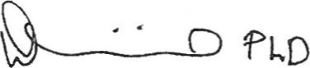
David G. Miricku Ph.D.
Licensed Psychologist

Exhibit C Detective Mon Report
IIUIL O - L—ameVVUUU r u rxepulL

Lakewood Police Department
Incident: LK21009476
Incident details: Bold notes added by Mary

Incident Type: | THEFT
Incident time: | 03/07/2020 18:00 - 03/07/2021 18:00
Reported time: | 03/10/2021 09:51
Incident location: | 350 HARLAN ST, LAKEWOOD, JEFFERSON CO 80226 (Beat: LPDS6) 80226
Incident status: | Cleared Exceptional - Prosecution declined
Reporting officer: | #2067 EVANS, ANDRES
Investigator: | #2006 MONN, KAYLEE
Summary: | RP called in to report several firearms have been stolen from his residence. The RP could not give a definitive time frame of when the firearms were stolen. The RP believes it was his exlover that took the firearms and sold them.
Involved Persons: I GAVE DETECTIVE MONN THESE NAMES AS POSSIBLE PEOPLE WHO MIGHT HAVE TAKEN THOSE GUNS – WAS TRYING TO HELP HER

Name: |  | LOPEZ, ANNA JUDITH Gender: Female
DOB: |  | 06/22/1991 THIS IS THE CARETAKER THAT I HIRED FULL TIME FOR ED AUG 1 2020 AND COUGHT HER BOYFRIEND GETTING READY TO STEAL EDS WELDING EQUIPMENT WHEN I GOT BACK FROM AR SEPT 23, 2020
Address: |  | 4225 HOYT ST, WHEAT RIDGE, JEFFERSON CO 80033 (Beat: WRPDBEAT3) (CADRESULT -
Telephone: |  | (Cell phone) (720) 419-7192 [Business)  (Other) (720) 290-9823 [Residence]  (Cell phone) (720) 290-9822 [Residence]  (Landline) (303) 419-1443 [Other]
Height: | 58" | Weight: 2001b Build:
Race: | White | Hair Color: Brown Eye Color: Brown

Name: HALLGREN, MARY Gender: Female
DOB: 01/08/1942
Address: NOT MY ADDRESS
Telephone: (Cell phone) (720) 301-0377 [Residence]
Height:Weight: 1351b Build: Average
Race: White Hair Color: Blonde or strawberry Eye Color: Hazel
Arresting officer: | #2006 MONN, KAYLEE | Arrest time:
Charges: | LK21009476 [1) 184401 | Adult 03/10/2021 Arrest

of45
warrant application
LK21009476 [1] (1) Adult AT-RISK-THEFT-VICTIM-$500 OR MORE 03/10/2020 Arrest warrant application
Narrative:
Arrest Warrant Application They didn’t arrent me
Name: DOB:  Address:  Telephone:  Height: Race: |  | LENCA, EDWARD HENRY Gender: Male  07/15/1953  350 HARLAN ST, LAKEWOOD, JEFFERSON CO 80226 (Beat: LPDS6)  (Other) (720) 671-2444 [Business]  Weight: 1851b Build:  White Hair Color: Blonde or strawberry Eye Color: Green
Name:  DOB:  Address:  Telephone:  Height: Race: |  | MANN, ROBIN ALEN  12/14/1968 I DON’T KNOW WHO THIS IS  4659 N WILLIAMS ST, DENVER, CO (4659 N WILLIAMS  (Landline) (303) 927-6418 [Other]  (Cell phone) (720) 628-9697 [Other]  (Other) (303) 858-8100 [Business]  (Other) (303) 292-5300 [Residence] Weight:  White Hair Color: | Gender: Male  ST DNVR)  Build:  Eye Color:
Name: | MOLITOR, ANTHONY Gender: Male
DOB: | 03/17/1947 This was the contractor I hired to build onto the West side of the barn. He didn’t take anything
Address: | JEFFERSON CO 80226 (Beat: LPDS12)
Telephone: | (Cell phone) (303) 319-9010 [Residence]
Height: | Weight: Build:
Race: | Unknown Hair Color: Eye Color:

Name: | MATTOS, JOHN Gender: Male
DOB: | This neighbor wanted Ed’s gun and had bought a couple from us when we had to get rid of loose guns so Ed could come home from rehab
Address: | 355 GRAY ST, LAKEWOOD, CO 80226 (355 GRAY ST LKWD: @HOUSING AUTHORITY OF THE CITY OF LAKEWOOD)
Telephone: | (Landline) (303) 807-9370 [Other]
Height: | Weight: Build:
Race: | Unknown Hair Color: Eye Color:

Name: | JAMES, CRYSTAL U Gender: Female
DOB: | 2000 DON’T KNOW WHO THIS IS
Address: | 7610 W WASHINGTON ST, # IN14054, INDIANAPOLIS, Jefferson IN USA 46231 (JP MORGAN
CHASE NATIONAL SUBPOENA PROCESSING CENTER)
Telephone: (Landline) (317) 757-7526 [Residence]
Name:
VARA,
ANDREW
Gender:
DOB: | 09/05/1966 THIS WAS OUR NOTORY AND LAST TAX MAN. NO WAY INVOLVED
Address: | , DENVER CO 80211 (CADRESULT -
Telephone: | (Cell phone) (303) 868-3376 [Residence]
Name: DOB:  Address:  Telephone: |  |  | LENCA, ELIZABETH ANN Gender:  06/25/1955 ED’S SISTER-IN-LAW (STEVE’S WIFE)WHO IS STILL MY FRIEND and would have no part of Kieth’s fraud  5729 1ST AVE N, WELLS, Ml USA 49894  (Cell phone) (906) 399-2802 [Residence] |  |  |  |  |  |  |  | Female
Name: |  |  | HEAD, DIANE ELIZABETH
DOB: |  |  |  | 06/16/1985 APS PERSON WHO WAS THREATENING TO ME and did incomplete investigation. She told people that my will and POA were not valid but never proved that.
 | Address: | 7470 W WARREN CIR, LAKEWOOD, CO USA 80227 |  |  | Gender: |  |  | Female
 | Telephone: | (Cell phone) (303) 618-4063 [Business]  (Cell phone) (303) 271-4268 [Residence]  (Cell phone) (303) 618-4063 [Residence]  (Landline) (940) 453-5721 [Other]  (Landline) (720) 453-5721 [Other]
 | Height: 5'9" |  |  |  |  | Weight: 1451b
 |  |  |  |  |  |  | Build:
Race: White Hair Color: Blonde or strawberry Eye Color: Blue

Name: |  |  | GOODWIN, JEANETTE Gender: Female
DOB: |  |  | 12/23/1954 The court ordered guardian caught buying gift cared out of Ed’s money and witness to Keith’s will.
Address: |  |  | 746 N NEWPORT ST, DENVER, DENVER CO 80020 (CADRESULT - 746 NEWPORT ST
Telephone: |  |  | (Other) (303) 881-9780 [Residence]  (Cell phone) (303) 322-3630 [Other]  (Landline) (303) 322-3630 [Business]
 | Height: |  |  | Weight: | Build:
 | Race: | Unknown |  | Hair Color: | Eye Color:

Name: | FRAZER-ABEL, VIRGINIA A Gender: Female
DOB: | 12/11/1966 Assigned conservator to Ed Lenca on September 1 2020 and locked up joint account.
Address: | 4704 HARLAN ST, Suite 250, DENVER, DENVER CO USA 80212 (FRAZER-ABEL LAW LLC)
Telephone: | (Cell phone) (720) 638-1465 [Residence]
Height: | Weight: Build:
Race: | White Hair Color: Eye Color:

Name:  DOB:  Address:  Telephone:  Height:  Race: | BAUGH, MARLENE  02/04/1960 Marlene who Keith got to make complaint so APS could take over.  32631 HWY 92, HOTCHKISS, CO USA 81419  (Cell phone) (970) 872-4440 [Residence]  Weight:  White Hair Color: |  | Gender: Female  Build:  Eye Color:
Name: BAUGH, MICHAEL STEPHEN Gender: Male
DOB: 12/22/1958 HUSBAND OF MARLENE
Address: 32631 HIGHWAY 92, HOTCHKISS, CO USA 81419
Telephone: (Cell phone) (970) 872-4440 [Residence]
(Landline) (303) 984-7929 [Other]
Height: |  | Weight: | 1651b | Build:
Race: | White | Hair Color: | Brown | Eye Color: | Blue

Name: HURTUBISE, KEITH ALLEN Gender: Male
07/18/1956 Our so-called Realtor friend I enlisted to check in on Ed when he became abusive to me and then turned on me and created a will behind my back. He knew the drug people Mike and Marlene Baugh from the 90s and told me to call police if they ever showed up again after he had them call and make a report to APS.
DOB:
Address: 5996 S JELLISON ST, Unit E, LITTLETON, CO USA 80123
Telephone: (Other) (303) 808-8202 [Residence]
(Cell phone) (303) 356-5508 [Residence]
 | Height: | 5'9" |  | Weight: | 1551b | Build:
 | Race: | White |  | Hair Color: | Brown | Eye Color: |  |  | Hazel
Name:  DOB:  Address:  Telephone:  Height:  Race: |  |  | LENCA, STEPHEN EDWARD  07/27/1954 ED’S best brother that I kept in contact with and were like family, visited often in Michigan and he wanted nothing to do with house or Ed once APS was involved as he had just spent 7 years of his life fighting APS over his parents estate.  5729 1ST AVE N, WELLS, Ml USA 49894 (Cell phone) (906) 399-3714 [Residence]  Weight:  Hair Color: |  |  |  | Gender: Male  Build:  Eye Color:
Name:  DOB:  Address:  Telephone:  Height:  Race: |  |  | LENCA, MICHAEL ALLEN  08/21/1969 Ed’s bad brother who is listed on pg 3 of last will and stole from Ed previously.  700 GODWIN AVE, GLENN HEIGHTS, TX USA 75154  (Cell phone) (469) 337-6787 [Residence]  Weight:  Hair Color: |  |  |  | Gender:  Build:  Eye Color: | Male
Involved Property:
, Ammunition : Center fire / Stolen / 5000RDS OF MISC AMMUNITION / O / $2,000.00 Ammunition : Center fire / Stolen / 2000RDS OF 9MM / O / $2,000.00
0 All others incid elec charged dart / Stolen / MISC FIREARMS - PISTOLS AND RIFLES / O / $60,000.00 0 L21019808 / Recording : Audio / Evidence / PHONE INTERVIEW WITH MARY 5/12/21
Involved Officers:

- #2006 MONN, KAYLEE (Investigator; Reporting officer)
0 LPD THEFT (Investigator)
0 #2067 EVANS, ANDRES (Reporting officer)
0 #000000 CAD INTERFACE (Reporting officer)
Reports:

Action log:
Type Entry time  General report: | Event time | Author | Link Log entry
Author: #2067 EVANS, ANDRES Report time: 03/10/2021 13:14
Narrative:
On 03/10/2021 at approximately 1114hrs I was dispatched to 350 Harlan St. in regards to a theft of firearms. Dispatch advised the reporting party had multiple assault rifles and guns taken from his home. The reporting party stated they know who took the firearms but does not know how long they have been gone. The reporting party stated the suspect is Mary Hallgren and she lived at the location some time ago. Ed never said it was me and knew it was not me as per recording of Ed. He had been told by the guardian who showed up to take guns when Virginia called for a locksmith that someone in the group was named Mary. Ed was easily confused and thought if he made a false police report that insurance would cover the cost of guns taken. APS by saying someone named Mary was in the group was a deliberate attempt to confuse him and implicate Mary Hallgren.
Upon arrival, I spoke to Edward Lenca (DOB: 07/15/1953) as he stood in the doorway of a shop on the south side of the residence. I then asked Edward if I may enter the residence and speak to him about what has transpired. Edward then gave me permission to enter his residence. Upon entering, Edward informed me, Mary (DOB: UNK), took his firearms from the three safes that are located inside of his shop
Edward informed me that he would not be providing me with the pages he found but would allow me to take photographs of them. I then took photographs of the pages Edward found and subsequently showed me with my department issued smartphone.
I was then informed by Edward that he noticed that all of his firearms were now gone from the three safes located inside of his shop on 03/07/2020 at approximately 1800hrs.In recording of Ed talking about someone taking his guns, he said he found the combo to two of the safes and they made him open them up. When this happened, the neighbor called me to tell me the doors to the garage and safes were open and you could see all the way to the back of the property. The last time that Edward looked inside of his safes and noticed all of his firearms being present was approximately one year ago. Inside of the safes there were an approximate total of 45 firearms. I was informed that there were approximately 30 rifles and 15 pistols inside of the three safes totaling approximately $60,000. Edward then stated that Mary did not have permission or the ability to go into the safes
Edward speculated that Mary was removed from his residence in September of 2020. Edward last spoke to Mary approximately three months ago and had a casual conversation with her. I left most of my stuff in the barn as I was basically homeless when I left the property. Off and on I would see Ed on the road walking to Cleo’s bar. There was one time when Keith let Ed drive the truck and he got stopped by a cop with no insurance or identification and another time he went to the bar and Cleo’s called me because he couldn’t remember how to get home. My daughter Michelle rescued him from the bar.
Upon asking Edward why he didn't make the theft report on Sunday, he informed me that he wanted to speak to his attorney first to decide on what to do. Edward then decided he needed to file a police report because of new legislation of mandatory reporting of stolen firearms. Edward did not want to be held responsible if his firearms fell into the wrong hands. I was told by Edward that some of his firearms are "assault rifles." Yes, according to GIOVANNI’s estimation in 2019 of the 3 assault rifles, there were not legal to remove from the property. When I left our home, I called the NFA to report them. They told me he had a right to keep them and did nothing. Upon asking Edward if any of his firearms are NFA items that include full automatic, short barreled rifles, or short barreled shotguns he indicated that he did not have any NFA items. Some of Edward's firearms are of AR15 and AK type rifles. Edward stated that he is a firearms collector and not a dealer but at one point in time he did have a Curio and Relic firearms license.
Throughout my conversation with Edward he requested to have a detective work in his case immediately and did not want a patrol officer to work on his case. I advised Edward that a detective was notified of the incident and would be contacting him.
I was also able to return to the shop and take photographs of the interior along with photographs of all three safes open showing they are now empty.
Edward advised he has difficulty of conceptualizing time and has been previously accused of having memory loss.
A supervisor was notified of the incident.
All photographs were uploaded into DIMS.
Nothing further at this time.
Supplemental:
Author: | #2006 MONN, KAYLEE | Report time: | 03/12/2021 09:02
Entered by: | #2006 MONN, KAYLEE | Entered time: | 03/12/2021 09:02
Narrative:
On 3/10/21 at approximately 1200 hours I was notified via phone by Agent Evans who was on scene at 350 Harlan St and was speaking with the listed victim in this case, Edward "Ed" Lenca DOB 7/15/53. Agent Evans advised Ed was reporting over 40 firearms that were stolen from his 3 safes and he wanted to speak with a Detective. Ed didn't know an exact time frame for when the firearms went missing but he suspected a Mary as the suspect. I advised Agent Evans to have Ed create a list of all the missing firearms and I would be in contact with him tomorrow. Virginia Frazer-Able admitted to my counsel, Tom Ripp that she called a locksmith to open the safes and went to the back of the property and sold his ammo.
I then looked into Ed's recent history in LPD databases. LPD Agents have contacted Ed several times in the recent past to include on 1/25/21 where Ed reported his pickup truck as having been stolen reference CR# LK21-3449. The next day it was discovered the truck had been taken by Jeffco Adult Protective Services (APS) as Ed was no longer permitted to be driving due to having, "severe memory loss" and recently was hospitalized for an evaluation. Actually under their care, he was caught driving without insurance or license.
On 12/8/20 Ed reported 2 handguns as missing which he said he usually kept under his mattress, reference CR# LK20-44002. What really happened to one gun is that in 2018 Ed let a bar buddy sleep on his couch. I left the premises as they were drinking and slept at my office for several days the guy stayed. When I returned, Ed could not find his gun. Ed used to walk around the yard with it loaded in his hand. He was drinking with this person so don’t know what all happened while I was gone. His memory was not working correctly. The pistols included a Walther PPK .380 and a Browning High-Power semi-auto 9mm, each worth $1,000. Edward reported his ex-girlfriend Mary as the suspect but stated he didn't want to "point the finger" at her. This case was listed as inactive on 12/9/20. I really dislike guns and was no longer on the property after I got a restraining order September 16, 2020 against Ed abusiveness.
On 9/15/20 Agents responded to Ed's residence regarding an intoxicated person where Mary's son, Hans Hallgren DOB 11/26/79 called LPD as Mary was hiding at the barn on the property and Ed was drunk and had a "Safe full of firearms." This is incorrect as Ed had quit drinking on Sept 4, 2020. He was having an attack because he had stopped drinking without VA help when he finally understood that APS had locked up his money due to his drinking. When Agents responded, Mary reported Ed as having been sober from alcohol for 2 weeks and he was "thinking more clearly." Mary said she was afraid Ed would try to access the guns that were inside of a safe in the locked garage. Mary feared Ed would remember the code to the safe and use the guns against her. Mary informed Agents of she and Ed's former relationship and said she was his Power of Attorney (POA). Mary was also advised of Colorado's Red Flag Law and no additional action was taken on scene by Agents. The associated case number was: LK20-33643.
Mary was also interviewed regarding CR# LK20-27301 and she confirmed Ed's fall in December of 2019. Mary also confirmed that she hired Anna, who was formerly homeless, to move in with Ed As full time caretaker. After staying at the house for 2 weeks, Anna left. When asked about the POA, Mary said her tax person, Andrew Vara had notarized and signed the documents however a Conservator had been appointed for Ed therefore the documents were not valid. This is a lie by conservator as They never took me to court about my documents and VA approved my POA. The burden of proof is on their side. I had rescinded my POA when APS took over. After that, another female, "Anna," This is the same Anna hired as live in caretaker August 1, 2020 moved in with Ed and possibly helped with cooking and cleaning. Ed also began to receive home healthcare from the VA 3 times a week.. I arranged for ED to have home health care after December 2019. Mary also confirmed having traded Ed's Corvette with his permission for approximately $1,500 worth of plumbing work on a sewer line. Detective Gilstrap also documented Ed's medical records from the Department of Veterans Affairs showed Ed had a history of, "alcohol-induced dementia." Only when drunk. Through the course of the investigation, the case (against Mary) was ultimately listed as inactive on 10/21/20. The APS case although it says here that it was inactive, they kept threatening me with paperwork until 6/5/23. I kept asking for a fair level hearing, which they finally dismissed due to sending the last paperwork to the wrong address causing me to miss the date.
On 5/7/20 Agents responded to Ed's residence regarding elder abuse reported by a social worker who said Ed was, "failing and falling." Upon contact with Agents that day Ed was described as appearing able-bodied, lucid and in good health. No further investigation was completed, reference CR# LK20-17450. This is the original report of Mike and Marlene. Nothing seems to be in order date wise here in this report and is a copy from Virginia A. Frazer. APS returned 3 times to try to catch Ed drunk so they could take over his life.
On 3/11/21 1 initially called Ed at the number listed in the records system however there was no answer, therefore I left him a voicemail message to return my call.
On 3/11/21 1 initially searched in LPD databases and found Ed's brother, Stephen Lenca DOB 7/27/54. Upon calling him, there was no answer therefore I left him a voicemail message to return my call.
I then called Mary to speak with her about what occurred. I initially asked Mary when she last saw Ed and she said it had been months and she recalled having seen him last at a garage or shop where he was driving his truck. The garage called me to report that they were fixing Ed’s truck because he had been down there so many times begging them but they didn’t know he was not supposed to drive.
I then asked Mary about Ed's gun collection and she said Ed's brother Steve and Ed's friend Keith, helped her sell Ed's some guns around November of 2019. She then added Ed had a memory problem and had fallen and hit his head in February 30,2019 and had a concussion. I asked if she knew if Ed had any firearms in the safe and she said she did, and then said, "unless someone got into them." Mary recalled Ed having 3 safes in the attached garage but that Ed hadn't been able to recall the combination for the past 2 years.
Next I told Mary that Ed reported his 3 safes to be empty and over 40 of his firearms to be missing. Mary immediately seemed shocked and surprised as she gasped and said she didn't know who could have taken the guns. Mary first thought Keith may have taken the guns as he has been Ed's care-taker since November of 2019. I then informed Mary that Ed was also reporting missing ammunition and she said she had ammunition locked up in the barn since approximately 1 month ago as she was afraid and called Keith for help. I left Sept 16, 2020 and Virginia Frazer-Abel admitted to Tom Ripp that she sold that ammo and she called a locksmith to open safe for people who took guns. She didn’t admit who it was.
When asked if Mary knew of anyone that was interested in Ed's gun collection, she said Ed would show his gun collection to all kinds of people in the neighborhood and said, "everyone knew he had them." Mary then said Ed's neighbor, "Jim" kept a watch on Ed's residence since Mary moved out and she said he may know who took the guns. Mary provided a phone number for Jim and I identified him through LPD databases to be James "Jim" Griffin DOB 12/8/56 with an address of 360 Harlan St
I then asked Mary about Anna who she had allowed to move in with Ed. Mary said Anna was the last person that Mary knew to have lived with Ed around the time frame of 8/1/20. Mary added she was out of town and when she came back into town, Anna was no longer permitted to live there. However, Ed let her back in. Mary said Anna’s boyfriend was caught trying to steal Ed's welding equipment
When asked for Anna's information, Mary said she had a picture of Anna's driver's license and vehicle registration as she had paid for State Farm insurance on Anna's vehicle while she helped to care for Ed. Mary later emailed me those documents which showed Anna's identity as Anna Lopez DOB 6/22/91. Mary did not know Anna's boyfriend's name but said he lived down the street from Ed. I later added the photos to DIMS. I then asked if Mary had any other individuals who she thought may have interest in Ed's guns. Mary sad Ed's friends Mike and Marlene wanted Ed's property and wanted to keep Mary away from Ed. Mary suspected they were involved in drugs and thought Ed owed a debt to them. Additionally, Mary said Ed's younger brother "Mike" who lives in Texas is a gun enthusiast and wanted Ed's guns in the past and has even stolen from Ed in the past. Mary had no further information to provide at this time but was very forthcoming with information and advised me to call her if I had any further questions. Shortly after hanging up with Mary, she had called me, sent me text messages and also emailed me several times. Mary provided information for Ed's Conservator, Virginia Frazer-Abel as well as Ed's Guardians, Jeanette Goodwin and Gayle Young. Mary also sent me a link to the Instant Checkmate website where she had a background check ran on Michael Baugh. I was not able to successfully view the information but added a copy of the email to this case.
While I was on the phone with Mary, Stephen had called and left me a voicemail message. Upon returning his phone call, I informed him of the case and asked if he was aware of Ed's condition. Stephen said Ed had fallen on 11/30/19 and suffered a bed head injury but recovered as of 2020. Stephen described Ed as, "doing better than ever" when he stopped drinking alcohol. He also stopped contact with Ed once APS was involved.
I asked Stephen about Ed's gun collection and he said Ed told him that he located the combination to his safe a couple days ago in an old phone book. When asked what type of weapons Ed had, Stephen said there was approximately $100,000 worth of firearms as Ed was an avid gun collector.
After speaking with Stephen I contacted Virginia to determine if she knew where Ed's firearms were or who may have taken them. Virginia advised she was appointed as the Conservator for Ed in January of 2021 (Actually Virginia took over starting Sept 1, 2020 and took checking account) and since then, she had never seen any of Ed's firearms and was told they were locked in his safe and were not able to be accessed. I then asked Virginia about the ammunition, and she said she had gone into the back barn and located ammunition and subsequently seized the ammunition and sold it to G and G Guns located at 8225 W Colfax Ave #A. Virginia often deals with "Warren" at G and G Guns and that was why she chose that business to sell the ammunition. Virginia then emailed me a receipt for the sale which totaled $2,388. A copy of the receipt was added to the case. When asked if Virginia had taken any of the firearms out of the house, she said she did not and said Ed was, "funny about it." I then asked Virginia if she was aware of Mary as having possibly stolen the firearms and she said she was aware. Virginia also added that Mary was being investigated by the Department of Human Services for financial exploitation which Virginia said would be reported to LPD soon. This is interesting as Virginia has since said to Tom Ripp that she called a locksmith to open one of the safes and they found cash as well as guns in there. Then later she told my counsel Tom Riff that they found guns under the floorboards? According to what Monn stated earlier in this writing, the case against me was listed as inactive 10/21/20 so why were they continuing to harass me? They were constantly serving me with papers until 2023 to keep me away?
I was then able to speak with Ed's neighbor of 10-12 years, Jim. While speaking with him I asked about Ed's gun collection and Jim said he wasn't really aware of it and had never seen Ed's guns. Jim was aware that Ed had 2 safes that Ed was unable to get into. TRUE A few weeks prior, Jim said he was keeping an eye on Ed's residence, but he did not have any keys to the property.
I then asked Jim if he knew who Mary was and he said he's known Mary and said she's been
with Ed since 2008. Jim said Mary would come over daily to check up on Ed and the property, however she had her own place now. Jim had moved into next door in 2011 and didn’t know us before then. When I started having difficulty with Ed, I stayed at my office but never discussed that with Jim. Jim then said approximately 1 year ago, Actually November, 2019 Mary moved into the barn on Ed's. I asked Jim if he thought Mary wanted Ed's guns and he said he didn't think she wanted them. Lastly, I asked Ed if he knew of another caretaker Anna, who Mary had hired. Jim said he did know of Anna and recalled her staying with Ed and helping clean up.
I then reviewed LPD databases and prior call history and located a phone number for Marlene Baugh DOB 2/4/60. Marlene was very polite and concerned for Ed's welfare while I spoke with her. Marlene described Ed as being her best friend for 40 years. I asked Marlene if she knew of Ed's gun collection and she said she did. Marlene added she knew Mary had sold several of Ed's firearms so that Meals on Wheels could come into the home. Marlene did not know how many of Ed's guns were sold or the location where they were sold.
I then asked Marlene about Ed's gun collection and she said she knew of Ed to have 3 safes with guns but Mary told her that Ed had forgotten the combination. Marlene then stated, "Mary is a liar" and said she was stealing from Ed and possibly even drugged him. They were lying to get me away from Ed and I didn’t know why until recently as they were connected with Keith and Keith was making a will to take the property. I asked Marlene if she thought Ed may have given his guns away to anyone and she said, "He doesn't give anything away I asked if anyone in Marlene's family had any interest in firearms and Marlene said none of her family members cared about guns. Marlene did add the Corvette that Mary sold was to go to Marlene's son, Michael P. when Ed passed away. Ed confirmed to me that this was not true and I have texts confirming this. He never promised her son the corvette. Ed had allowed Michael P. to drive the Corvette after Michael P's wedding and told Michael P. the vehicle would be his someday. Since living with Ed these people only stooped one time in 2010 to visit Ed at that time but he did not tell me who they were. While speaking with Marlene further, she advised the ATF had come into Ed's house 15 years ago or so and went through his guns and registered him as a gun collector. Marlene advised Ed added another rifle to his collection approximately 1 year ago when Ed's father passed away and he inherited a rifle as well as from him. I asked her if she knew of Ed to have loose guns in the residence and she said he had approximately 6 guns in the house.
Next I asked Marlene about Ed's memory concerns. Marlene said she was unaware that Ed had a bad fall until her last visit with him. Marlene added she feels bad for Ed as she appeared to stary crying as she spoke with me Marlene said Ed was not being cared for properly and that she had been the one to call APS to report Mary. Marlene advised Mary had taken Ed's phone and since then, Marlene has been unable to get back in touch with Ed, therefore she has been sending him postcards and letters. Marlene then told me of a time when Ed gave her flowers in a vase and she still held onto the vase. I took Ed’s phone one time to fix it. I got him a new phone service when APS took over as they didn’t pay his bill. Then he lost that phone.
Lastly, I asked if Marlene knew of anyone that may have an interest in Ed's firearms or in any of Ed's property items. Marlene said Ed's brother, later identified as Michael Lenca DOB 8/21/69, who lives in Texas. Marlene provided his phone number. Marlene described Michael Lenca as being the "black sheep of the family" but said he also wants the best for Ed.
After speaking with Marlene, I located another phone number for Ed and was able to speak with him about his firearms. Ed advised he was missing about 50 firearms and 12 of those firearms are "high end assault rifles." In the afternoon hours of 3/11/21 1 responded to Ed's residence to meet with him. Ed provided me with a 3-page yellow notebook paper list of his 40 stolen firearms.
I took a photograph of the above list and uploaded it into DIMS.
Ed said Mary had lived in the back with him for a couple years when he described his relationship with her as being, "Platonic." Well, sex ended with us when he got treatment in 2012 for prostate cancer. We still agreed to stay together until the end of our lives.
Prior to leaving Ed's residence I asked him when exactly he last recalled seeing his gun collection. Ed advised he was not good at telling time and said it had been "Several years." When asked if he had any sort of records or documentation for his collection, he said he did not. Ed advised he thought his guns were safe as they were locked up in his safes. I then asked Ed about the ATF visit and he said the visit was as a result of an online purchase he made for gun parts which prompted the ATF to visit him 3 days in a row. Ed said the ATF never viewed his gun collection or conducted an inventory. Ed then opened one of his safes and showed me that only 1 handgun and 1 long gun remained in his safe. Ed was unsure as to why those 2 weapons were left as they both were worth some money as well. Anna can attest to those guns still being there and also the health care worker at the end of her tenure.
Health care worker Texted me when I was no longer living there that she found one of the safes open with automatic guns that she could see and asked if she should report it and said she would not be allowed to come there anymore if she reported it. I asked her to close the safe and it was up to her. I think she reported it and after that her number was disconnected. I still have pictures of her texts.
I then asked Ed if Mary's son Hans had ever shown any interest in Ed's guns and he said he did not. Hans never came over to visit us, I went to visit him. Hans only visited one time in 2009 and gave his bird Lucy to Ed. Since then the only time Hand paid a visit was SEPT 15, 2020 when we called the police on Ed psychotic episode. I asked Ed if he suspected Mike or Marlene and he said he did not. When asked if he suspected his friend Keith or his brothers Mike or Stephen, he again said he did not. Ed added he hasn't spoken to Mike since their father's funeral in 2014. Funeral was in 2015 see Picture of me with Ed at funeral. Marlene reconnected Ed with Mike in 2020 after I left and Ed could not remember anymore that he hated brother Mike after his VA hospitalization so health care worker told me Mike called him a few times. When asked if he suspected Anna who was homeless and lived with him for a brief period of time, he said he didn't recall who she was and he only suspected a Mary. I informed Ed that Mary had stated Anna and her boyfriend were interested in Ed's gun as well as his welding equipment and I asked if he noticed any of his welding equipment missing and he said it was all there as he pointed to large machinery items in his garage. We caught them getting ready to steal the welding equipment but stopped them.
When asked who Ed last showed his collection to, he said it was a few years ago and was the former owner of the Goodyear Tires at Alameda and Wadsworth. Ed seemed adamant that Mary had been the one responsible for having stolen and likely sold his firearms….
After speaking with Ed I returned to the LPD station where I called the Old Steele Historical Firearms in Littleton to review any possible sale records with Mary. I was advised the store staff would look into it and call me back.
I then called Ed's friend Keith however there was no answer, therefore I left him a voicemail message to return my call.
I also received a missed call and voicemail message from Virginia advising on 9/15/20 Mary had filed a Red Flag case on Ed reference 2020CV170 however on 9/16/20 she filed a motion to vacate the case.
On 3/12/21 1 received a missed call and voicemail from Keith. When I called him back, Keith advised Ed was a friend of his and he knew of Ed's gun collection. I asked when he last saw Ed's collection and he said he was around 2017 or 2018. Keith knew of Ed to have 3 full safes of guns but that Ed never wanted to sell anything. When asked about Mary, Keith said she was in and out of Ed's life over the past 10 years and she had sold some of Ed's guns to Greenland Guns. Keith seldom visited us until I invited him to check on Ed as he had become abusive. I then asked how Ed's memory seems and Keith said he visits Ed a lot more frequently now and noted Ed seems to be getting better and hasn't been consuming alcohol. Keith described Ed as, "back to how he used to be." Ed’s personality was somewhat back to what it used to be but he had lost much of his memory. Also, someone was supplying alcohol to Ed as in 7/12/21 I found Ed passed out drunk and unconscious and called for welfare check on APS care. After this report no alcohol was supplied to him that I am aware of. (see attached: pictures with date I took and sent to detective Monn).
Ed doesn’t remember but In 2014 we moved into the back house (barn) to rent out the front house and there was no room in the barn for all our extra stuff so all the things we didn’t need were put into containers in the very back of the back yard. Unfortunately, rain got in and ruined most of the stuff in the next couple of years that we were trying to save. I lost all my VCR tapes and many documents and books. Ed’s ruined extra clothes that he didn’t wear got ruined and were thrown away.
After discussing his additional missing items, I asked Ed if there had been any of Mary's property left at the house. Ed said she had an oven which was used in her dentistry business and very few other items. I then contacted Green Mountain Guns and The Gun Room however neither business had purchased any firearms from Mary or Hans. I was not able to locate a Greenland Guns business in Colorado
On 3/16/21 1 received via email from Sean, a copy of the Financial Durable Power of Attorney which was signed by Edward and Mary with the notary also having signed as Andrew Vara with ID #: 19974016242 and dated 6/29/18. Sean also sent me a letter to the ATF from Mary, requesting information on any title 2 or NFA firearms owned by Ed. Mary's signature was the only one on this form and was dated 7/22/20. I then asked Sean if he primarily interacted with Mary or if another store employee had interactions with her. Sean said it was primarily him and the shop owner "Geo."
On 3/17/21 1 responded back out to Ed's residence to speak with him further about the case and also pick up additional documents he drafted regarding missing handguns. While at his residence, Ed provided me with the vehicle title for a '78 Toyota 2-door with VIN: FJ400265801. The title had Ed's name listed on it with a purchase date of 11/01/89. Ed had sold this vehicle long ago and then after 2008 I bought a white utility truck that he kept driving and would not stop, so I finally sold that in about 2014. This forced Ed to buy his Ford pickup truck. I had been supporting him for 5 years and wanted him to take care of himself.
On 3/17/21 1 contacted APS case worker Diane Head and spoke with her about the case. Diane stated Ed was appointed a private guardian and an attorney as a result of APS investigations. Diane said they were investigating caretaker neglect for Mary however no criminal charges were substantiated. Diane further advised APS had accessed Ed's VA records and had a Neuropsychological evaluation completed for Ed. Yes, they completed this right after his psychotic episode and VA treatment. Ultimately, Diane said the POA that Mary had over Ed was found to be invalid (This is a lie as that was never proved, my POA was valid, and they chose to not take me to court and closed the case) as Ed was a chronic alcoholic and was unable to consent to the contract not in 2018 when I got the POA. Diane said Ed's medical condition was alcohol-related Dementia. Diane further described Mary's actions as being egregious as she said Mary had blatantly used Ed's money to finance herself. I only used money from anything sold for the property and invested all the money I earned into the property during all the time I lived with him
On 5/8/21 1 received a text message on my work cell phone from Mary advising she had just found out that day that Ed has his gun collection sold out of his safes and he made a false report. Mary further said Ed has, "plenty of cash" that his conservator doesn't know about. Unfortunately I told her about the cash Ed found he had forgotten about hidden in the back of the safe after APS took his guns. I recorded his conversation. Evidently she reported this to APS and they came and took the money from Ed. Later Ed couldn’t remember how much money they had taken from him and told me $40,000 which was from his parents estate. Ed was confused and memory not reliable.
Mary also said she suffered domestic abuse with Ed and she described him as being a "bad person." Ed was not a bad person only when he started drinking excessively after Dec 2019. To Ed’s credit, he tried hard to manage his alcohol problem. We had a good respectful relationship over the years, he told me many times that no one else had ever treated him the good way I treated him. He only became an ugly bad person starting December 2019. It was domestic abuse as I believe I triggered his feelings of rejection, and he started threatening me constantly when under the influence of alcohol. I was ashamed that I was living under those conditions hiding in the barn and have a recording of him walking through the downstairs of the barn yelling and threatening me when drunk so I kept to myself and would stay away after that.
On 5/12/21 at approximately 1021 hours I called Mary and recorded the approximately 53minute conversation on my desk phone.
During the conversation, Mary said she and her daughter Michelle Mottler DOB 5/31/62, went to Ed's house over the recent weekend and asked Ed how he was doing and asked about the guns from the safes, and she said he started to tell her, "Mary took them." Ed then told Mary he had a bunch of money from the. Mary then began talking about the guns and said she knew he had, "automatic machine guns" but she only knew of 1 handgun which was a revolver that was kept in his top dresser drawer. Mary then said several of the neighbors to Ed had looked at Ed's guns. Mary said Keith likely found a way to get rid of the guns from the safe and she again reiterated that she was scared of guns
Next Mary began asking about whether I contacted Marlene, Mike or Ed's brother Mike about the missing guns. Mary then asked me to check into Ed's phone and I informed her that he recently got a new phone from the conservator. When I asked Mary if she had ever taken Ed's phone she quickly denied it by saying, "No no no" and said he lost his phone from walking down the street. Ed lost his phone once in his recliner and one time walking down the street to Cleo’s bar. I also arranged for a new phone and he lost that.
As I was speaking with Mary she said in February of 2019 Ed had been drinking too much so she took Ed to Dr. Fishman to a detox program where Ed only stayed for 4 hours and then took a taxi to return home. Mary said Ed drank on and off after that and Ed feared his cancer would come back. Mary then said at that point she and Ed were trying to get a "refi or a reverse mortgage" on his house. When I confirmed with Mary the house was actually paid off, she said it was. Mary then said she was busy with work and on November 30th of that year Ed had fallen and hit his head.
After Ed's fall, Keith assisted with returning Ed to the home. Mary stated Ed went "right back to the bar." Mary then said Keith took over checking on Ed at that point and said, "l wasn't even checking on him." Mary added Ed was "pissed at me" for moving to the barn and "triggering his rejection." Mary then said she didn't let Ed in the barn as she described it as being, "my space. Mary then began saying when Ed would get really drunk he would get abusive. When asked if she ever reported any of the abuse to LPD she said on 9/15/20 she got a protection order. Around that same time Ed noticed APS locked up all his funds. Mary then said Ed quit drinking "cold turkey." Mary then mentioned another incident which she said was 2 weeks later on 9/15/20 where Ed, "just went crazy" and was "extremely frightening" and she had to hide in the barn until LPD arrived. Mary said she wasn't even living at the house at that time and only came to the house to get things and was otherwise staying with her daughter or at her office. Mary said the day after she called the VA and then went to LPD and got an Extreme Risk Protection Order.
When Mary spoke with the VA she said they were concerned Ed may have been having a stroke the previous night when she called LPD, therefore she brought Ed into the VA. While at the VA Mary said she, "Didn't feel like I had any more responsibility for him, I'd done enough, I was trying to get away from him." Mary then said the VA kept Ed until 9/23/20 and said he was, "totally fine" according to his medical records. Mary said she did not go back after that because Ed was "just a nightmare." Mary added the same day Ed was admitted into the VA she rescinded the protection order. (And I signed over the deed to the house to Ed in case they would need it for his care and took my name off the joint checking account. See attached: deed and resending POA)
Next I asked Mary if Ed had ever been diagnosed with any mental or medical health diagnoses and she said, "No" and, "He was cognitively okay and able to take care of himself." Mary then added she had Ed's VA records and that his lawyer had a disc with all his records. I asked if Ed was ever diagnosed with alcohol induced Alzheimer's she said, "not that I'm aware of." Mary then began laughing as she said most of Ed's problems were alcohol induced. Mary said, "How they can blame me for Ed's drinking, I just don't get it." Mary then said, "l don't want him to get away with his bullshit." Mary then began talking about Ed's guns and she said she never thought about the value of them. Mary then recalled Ed showed the plumber his gun collection and the plumber asked Mary how Ed got those guns on a cement worker salary. Mary then said she asked Ed about how he acquired all the guns and Ed told her he had a meth business back in the 90's that Mike and Marlene were apart of and he paid cash for all the guns. Mary then explained she had called the ATF on Ed's guns before and said he had thought about killing a few people before and she was afraid of him. Mary said she wanted them to take the guns under the Red Flag Law but was told no. Ed contemplated killing Connie before she died suddenly of cancer and he also contemplated for a two-week period of time of killing his last employer for letting him go, but he knew he couldn’t get away with it. He was a trained killer in the Marines. I knew if he ever got mad enough at me, he would try killing me when I found all this out. Ed would keep things to himself but after his hospitalization at the VA he admitted everything.
I then re-directed the conversation and asked Mary if she had an approximate value of how much she spent on Ed or his house. Mary said on her credit card she had spent $7,000 just at Home Depot and provided all the receipts to APS and case worker, Diane Head. Mary said she also spent "a lot of cash" to have a contractor build for her and she had a letter from him. Mary paid the contractor with checks and cash and during the year of 2018 and 2019 where she made $100,000 both years. Mary then described she was living in the barn with mice that came in. Meanwhile Ed was staying in the house and Mary was complained on for not cleaning the house and she exclaimed, "It wasn't my job. His house was better than mine."
When I asked to look at Mary's bank statements she said she had a business "making teeth" and that it felt that I was going "a little far." I confirmed with Mary that I was looking to confirm how much of her money contributed to Ed's care and she said after APS she contributed to Ed's care to include buying food and paying for the hired care-taker Anna's car. I asked to look at the bank statements during that time and she said some of the money was for Ed's care and explained, "l was fixing up the place." I then asked Mary if the money spent on Ed was as a result of items she sold or her own income she said it didn't even matter because she had financial and medical power of attorney. Mary said, "l had the right to do that, so If you want to take me to court, I have the paperwork." Mary then said she provided her documents to APS. I then told Mary I was also reviewing Ed's bank documents and would like to review hers as well. Mary said she would look for a print out.
Mary then said Ed's "thing" was spending his money on alcohol on cigarettes. Mary then redirected the conversation and asked if I spoke to Anna or another hired home health nurse "Joanne" or "Janet" about Ed's care.
When I asked Mary how the money went into the property she said she spent $30,000 or $40,000 cash on the building additions. She said, "That was probably part of the cash." I then asked who's benefit the remodel was for and Mary became defensive and said, "Well it was for the property, I don't have the property anymore." Mary added "We" were trying to have a place to live FOREVER and said she made "investments into the property." Mary then said when she lived in the house before she had "totally remodeled the house and refinished the floors." Mary said then she put "more than $40,000" into the house at that time and that was why Ed willed her the house in 2012. Ed also gave me that will because not only did I invest much money and time into the property but also I settled with his exes’ family for $19.000 so her family wouldn’t’ fight him on the house as they were threatening him to take the house. Mary said Ed didn't work for several years and she supported both of them. Mary then added, "I've lost everything, I got nothing out of that." Mary again went on another tangent saying previously she spent $40,000 completely re-doing Ed's teeth and a "full mouth reconstruction."
I then informed Mary I had spoken to the new owner of the motorcycle, Martin Parras who said he wrote a cashiers check. Mary said she didn't know who's account the check went into.
Next I asked Mary about the Corvette sale and she said, "We traded it for some plumbing work." Mary said Mark told her he did $1,500 worth of work and dug out 6' between the barn and house to fix a pipe. Mary said Keith also tried to find a buyer for the Corvette but it was rotted out and 1 door wouldn't open. Mary said she was trying to clean up the yard. Mary also said she had a receipt from Mark for the work.
I then asked if Mary had provided vehicle titles to Martin or Mark for either vehicle and she said Ed lost all the titles and Mary had to re-order them. Mary added Ed was "involved with things at that time."
Next I asked Mary about any of the sale profits from any of Ed's items went directly into her bank account and she said, "Well the, I don't remember, I wouldn't know."
After speaking with Mary, she sent me several text messages asking to meet at Ed's house so she can get her bicycles that were hanging on the fence and she also wanted to show me everything she had built. Mary said, "If I was there Ed would have to tell the truth." By this time I realize she had turned against me and hired a lawyer to stand between Lakewood police and me. The DA refused to charge me and closed this case. See attached: text from my lawyer saying case is closed.
Detective Monn from there sent Virginia all my bank account information, credit card info, and all my personal information that should not have been shared unless there really was a case proven against me.

A few additional comments in case written by detective Monn are as follows:
“Ed advised when the building was first built it cost approximately $12,000. As I spoke with Ed further he seemed distracted and when I asked where he was he said he was at Cleopatra's bar. I advised Ed I would call him later.
On 5/13/21 Mary sent me several additional text messages regarding meeting up with me later that day. Mary asked if I was coming by myself and I told her I was not and she said she would prefer that as she wanted to have a friendly conversation. Mary said she would meet me outside and see what she thought. I was realizing she was trying to build a case against me.
On 5/13/21 at approximately 1500 hours, Detective Russell and I met with Mary at her office located at 494 Sheridan Blvd unit #CIOO room #4. Mary initially waited for me outside the building on a bench and then decided to allow me and Detective Russell into the building. Mary led us directly to her office area which was about the size of a walk-in closet and was very cluttered and crowded. Inside she had a computer and apparent dental equipment laid out along a table. There was also a small bed in the room. YES, I WAS LIVING AND WORKING IN THAT TINY ROOM.
Mary then began going through a large approximate 1 % by 1 h foot gray cloth storage box that was nearly overflowing with paperwork and documents related to Ed. Mary handed me various papers from inside the box that were disheveled and didn't appear to be in any particular order. Mary only let me view the documents for a few seconds before going through and looking for other documents. While going through her documents Mary had picked up one of her tax returns from a previous year where it showed she had made an income of approximately $180,000 BEFORE TAXES which was a shared business with her son.
I then asked Mary about her bank statements for Chase bank and she logged into her account number which I heard her say aloud some of the account number digits being asked Mary if she would be willing to provide her bank statements for me to review to see how much money she spent on Ed and where the money from the checks written from Ed's account to her had gone. Mary then said she had remodeled Ed's house from June of 2017 when she moved in until about January of 2020.
I then asked Mary if she had any other bank accounts where she may have spent money on Ed and she said she had a Discover and a Capital One card but the Capital One account was closed.
When I asked Mary about the list of checks that I had received from Virginia she acted confused and said she didn't know where the money went from the checks but said it was money that she deserved if she wrote a check and had power of attorney and was on their joint checking at the time.
Before leaving Mary's office I asked her if I could take the box of documents and make copies of them and then return it to her and she agreed and packed everything up and provided it to
me. When asked about her bank statements Mary said I had her permission to call her bank and get the documents. I did not give her permission to get into my bank account. They were going too far and I could sense that she was on APS side. At that time, I had no place to live, was trying to be safe from APS and ED, and trying to keep my health under all the stress and now I had a police woman threatening me. I also asked Mary if she could call her bank and ask them to put together a pdf document from June of 2017 through January of 2021 when she moved out and had no further contact with Ed.
I then went directly back to the LPD station and began reviewing some of the large and overwhelming stack of paperwork Mary provided. As I was doing so Mary sent me another text message regarding the validity of her power of attorney. Mary said Ed's friend "Paul Shada" and her "tax man... Andrew" both witnessed the power of attorney. Mary later texted me a phone number for Paul.
Mary continued to send me text messages saying "Karen Denan" was a psychologist at the VA and she had done an evaluation on Ed and cleared him "more than once." Mary said after Ed hit his head, Mary wanted him evaluated to make sure he was okay. This is true. After his fall and he had recovered, I asked the VA for a checkup to make sure Ed was OK.
On Saturday 5/15/21, on my day off, Mary sent me a text message asking if a locksmith had gone to Ed's place on March 5 th , 6 th or 7th to open his safes. Mary also asked if I had checked Ed's phone and said if I hadn't done so yet then, "You're not really investigating who took those guns out of the safes." Mary then said, "l need to hire a private investigator or call the FBI because as you know some of those guns were illegal to move. Since he's trying to blame me I need to find out for my own defense before it's too late." I did not respond to Mary. This is true. I hired a private investigator, but he was a rip off so that only lasted a week as he did nothing. I had to fight with my credit card company to return their payment.
On Sunday 5/16/21, also on my day off, Mary sent me numerous text messages advising of a guardian abuse story on the news and said, "They're just trying to get rid of me because I advocated for Ed."
On 5/26/21 at 1328 hours, Mary provided the phone number for Andrew Vara who was the notary for her Power of Attorney. Mary also said I need to call Paul still as well as both he and Andrew could verify her power of attorney. she said, "No you need to check out my power of attorney." I did not message Mary any further.
On 6/4/21 1 called Paul however he didn't answer, therefore I left him a voicemail message to return my call.
I then called and spoke with Andrew about this investigation. Andrew provided his DOB as 9/5/66 and said he has known Mary for the past 10-15 years and they used to be neighbors with one another when Mary lived in Westminster. I asked Andrew about the documents he notarized for Ed and Mary and he said he recalled going to Ed's house to notarize several documents. Andrew described both Ed and Mary as being, "fine" during his time with them. Andrew said he went to Ed's house twice, once on 6/29/18 to notarize the POA documents and again on 9/3/20 to notarize a "statement." This was when Ed wanted Andrew to notarize a statement that he wanted APS out of his life. Andrew was unable to recall any further specific details for the statement. I asked Andrew how Ed appeared both mentally and medically and he again said Ed was fine. I asked if Ed was able to comprehend and sign the documents and he said he was. Andrew had nothing further to provide regarding his contact with Ed or Mary in this case.

Exhibit D Will made out to Ed Lenca October 7,2020
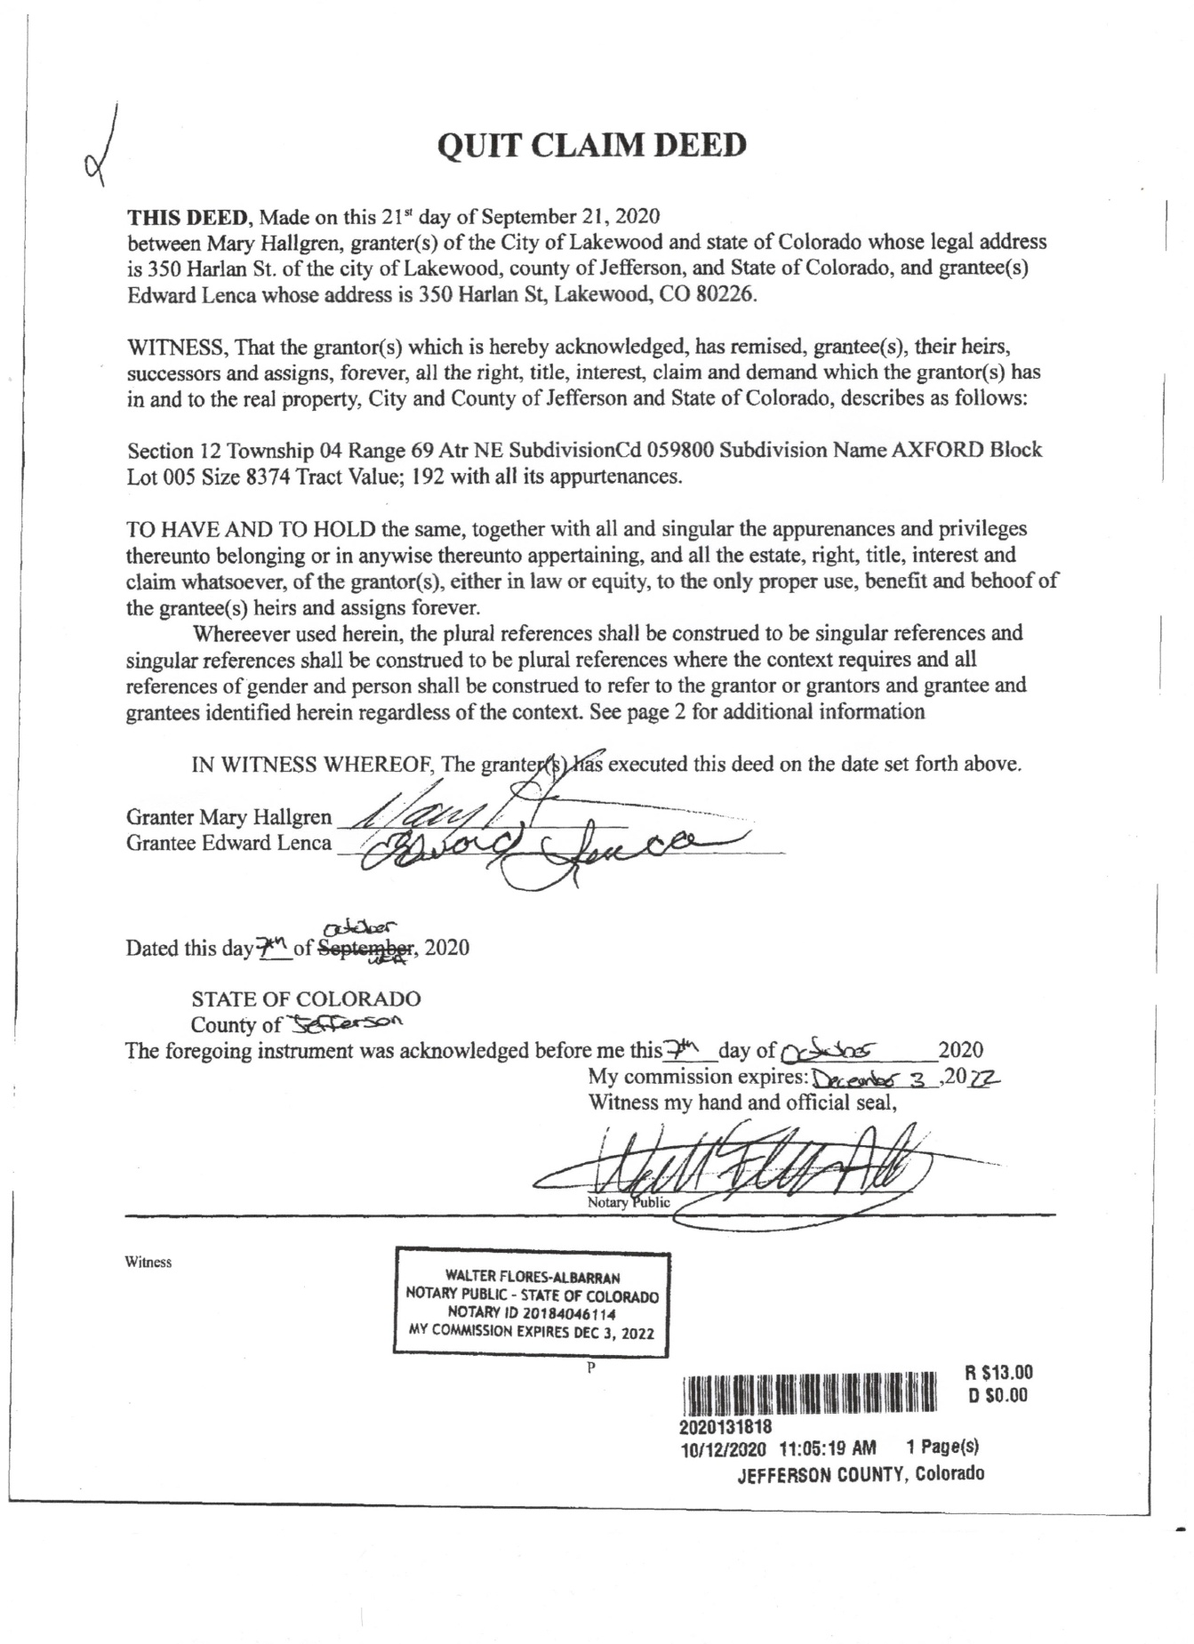
Exhibit E Steve Lenca Text to Mary doesn’t want house
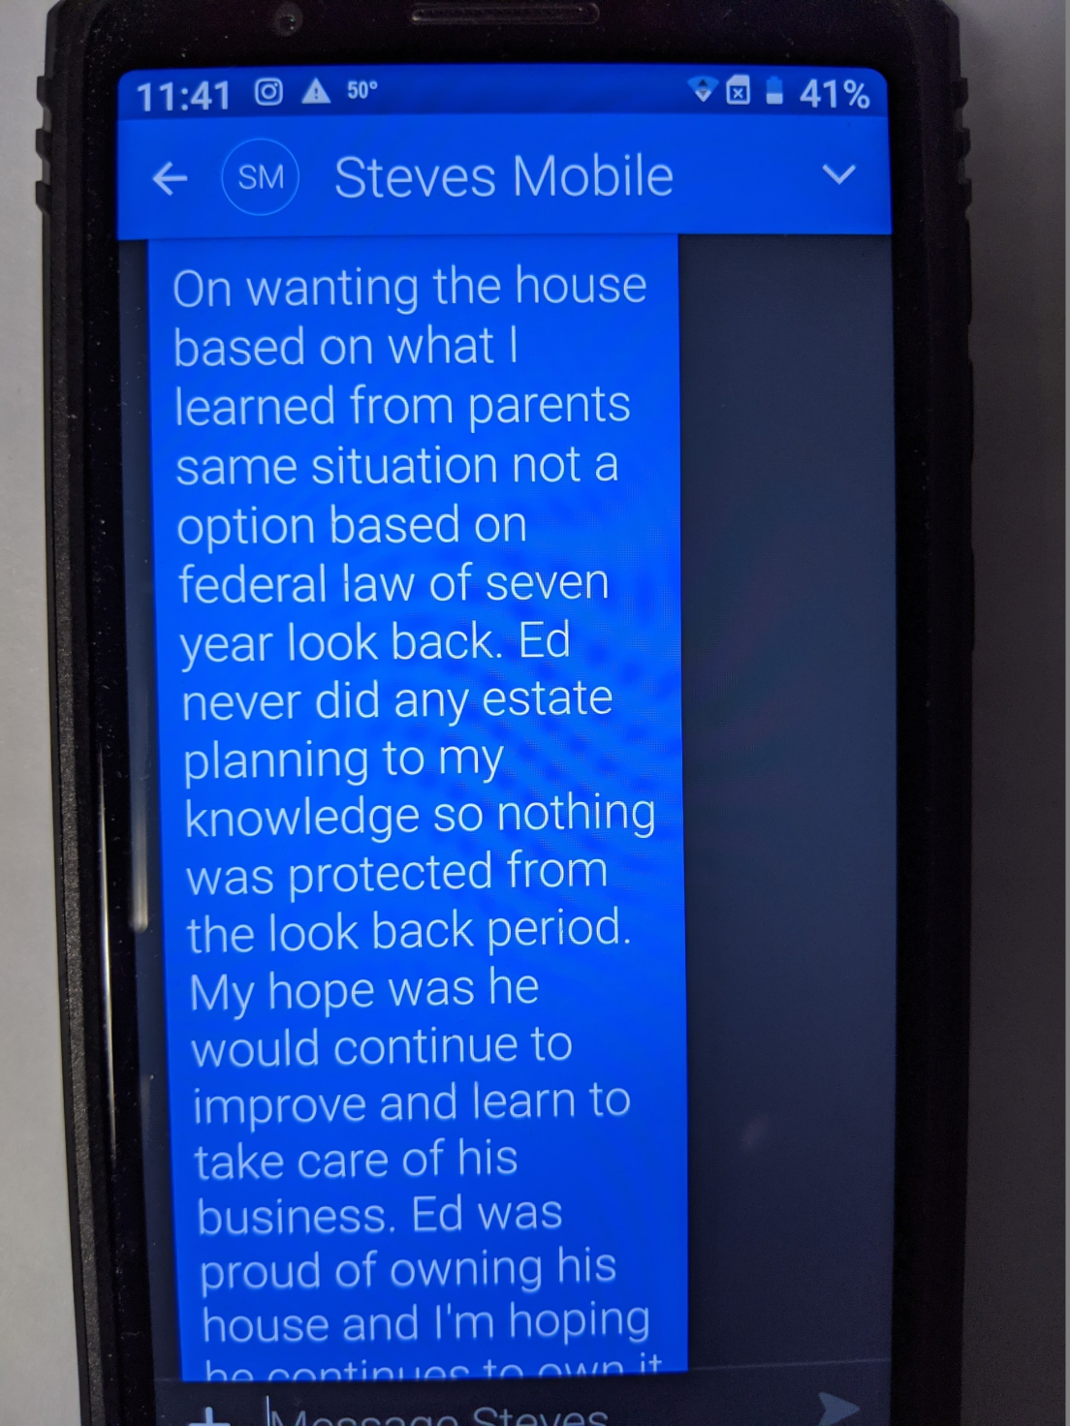

Exhibit F Ed passed out under APS care
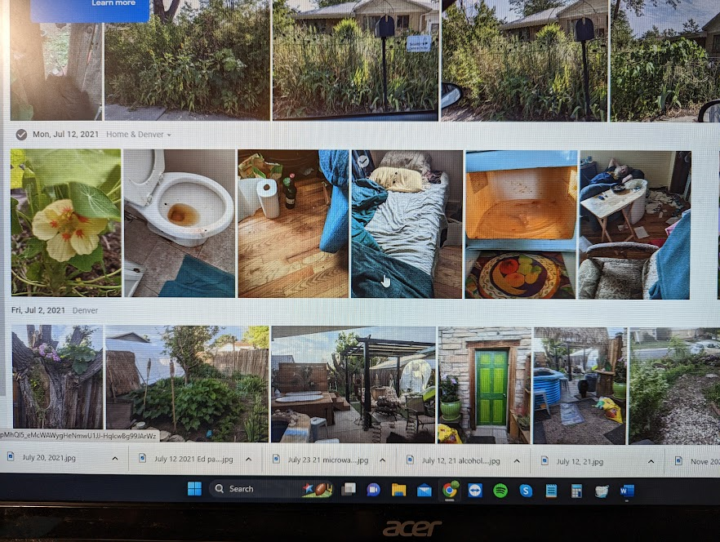

Exhibit G VA records and proof of common law wife
